**Kuberenetes:**

why k8s?

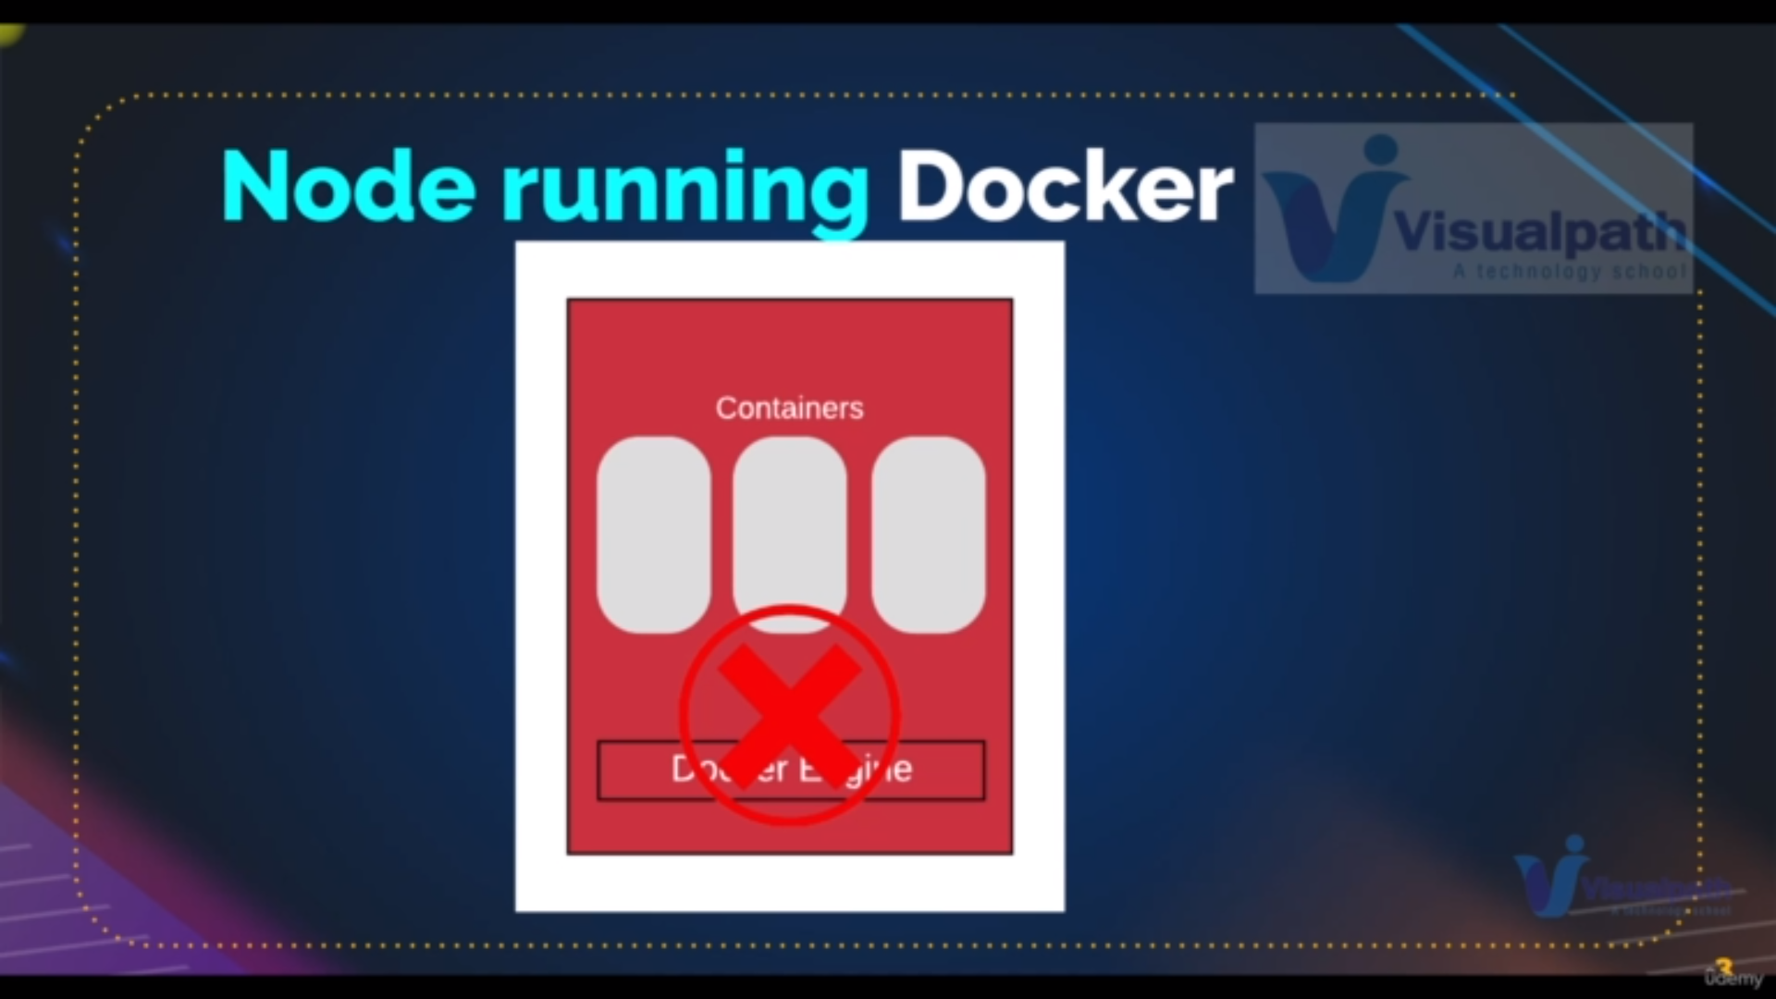here if docker enging shutdoe all containers will not work

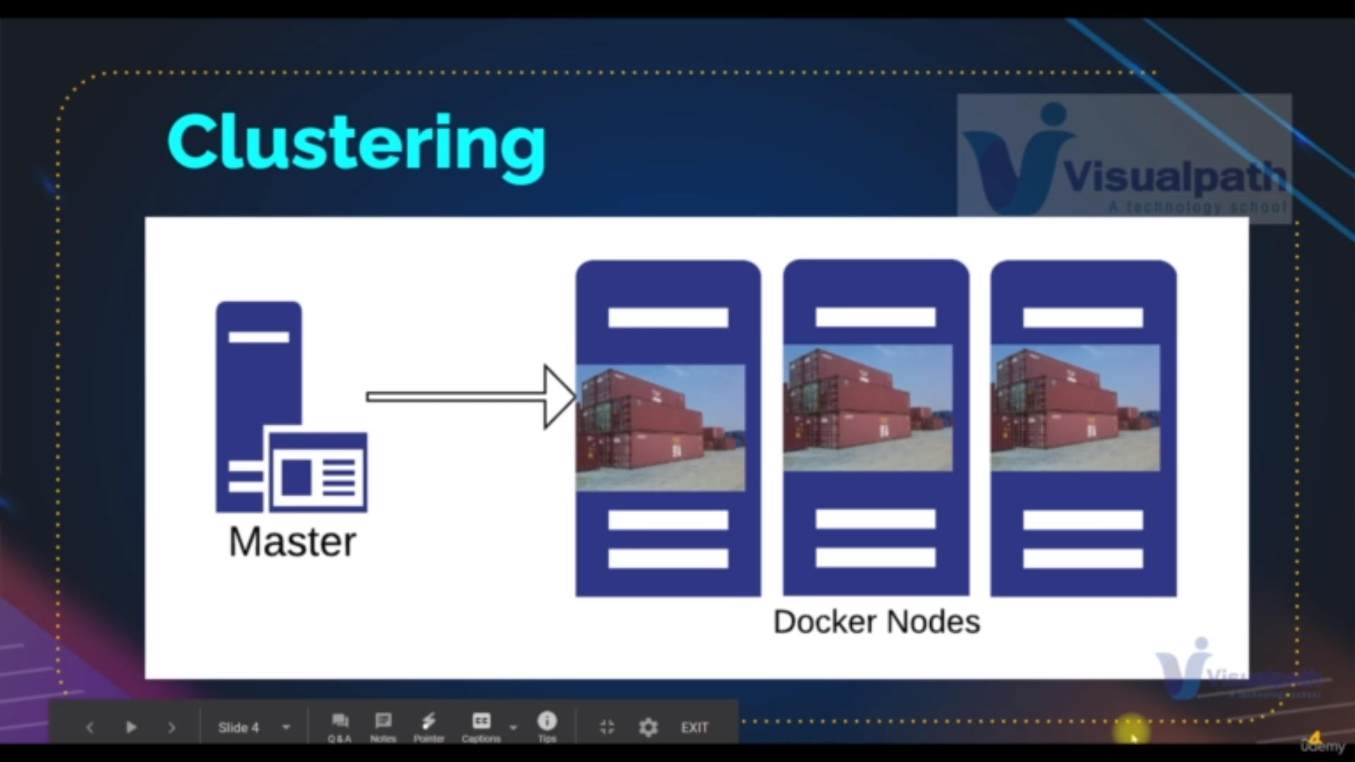k8s provide multiple docker engines as docker nodes

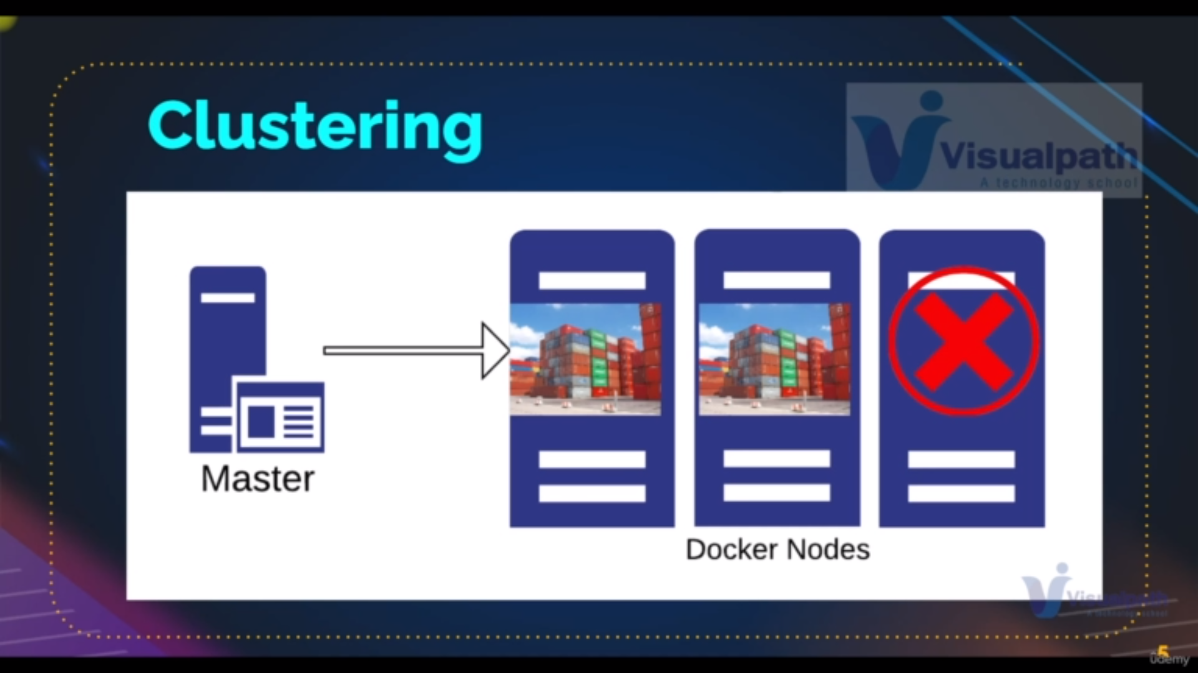so as for first picture if fails it will go for another another docker node

and creates the containers with the container image

**ans: mainly replication ,autoscaling**

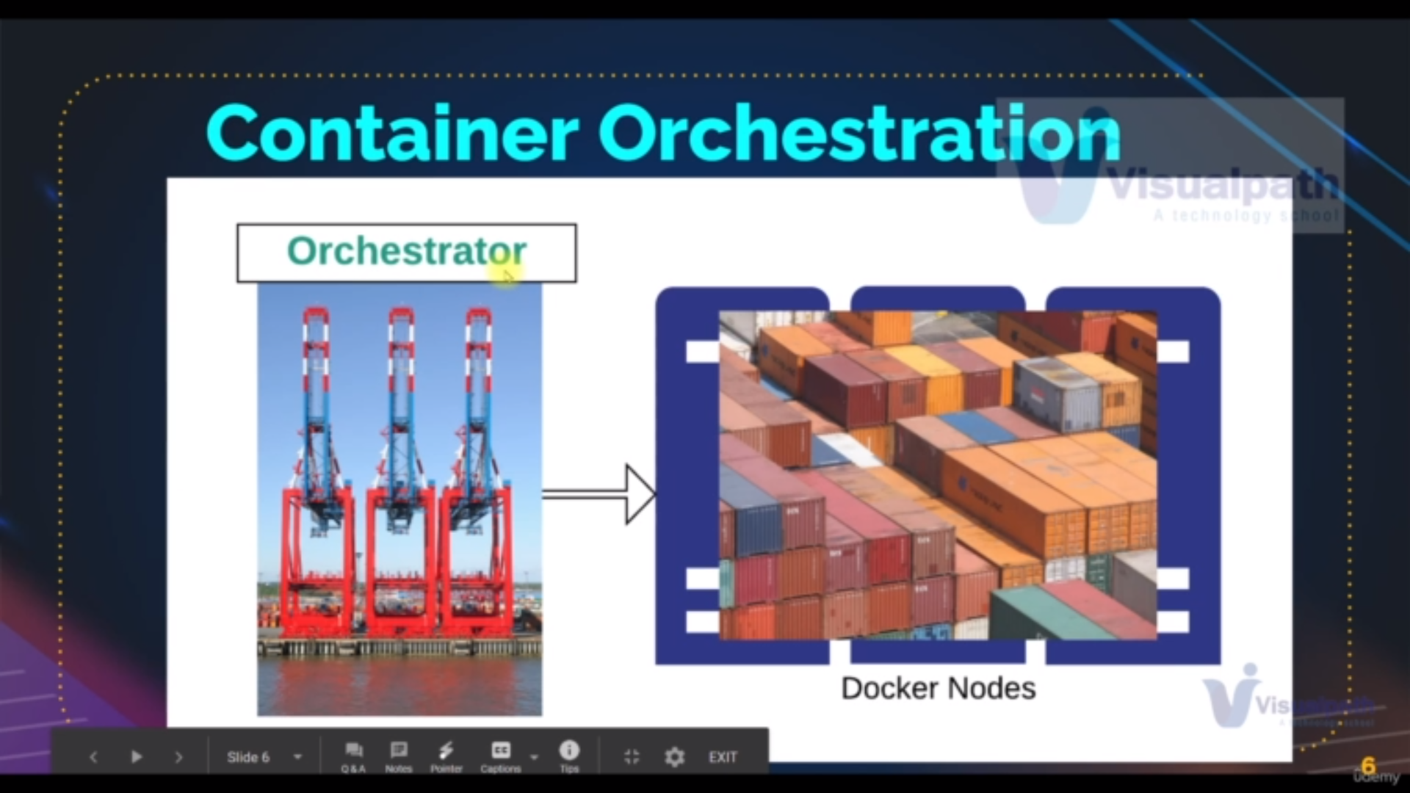k8s has a instance as master node which is Generally create docker node on different node or different instance called as slaves node or agent

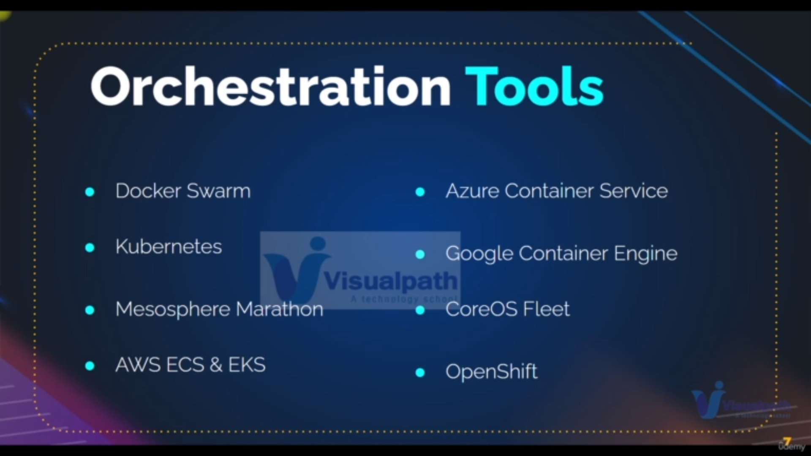these are tools that are available for master node

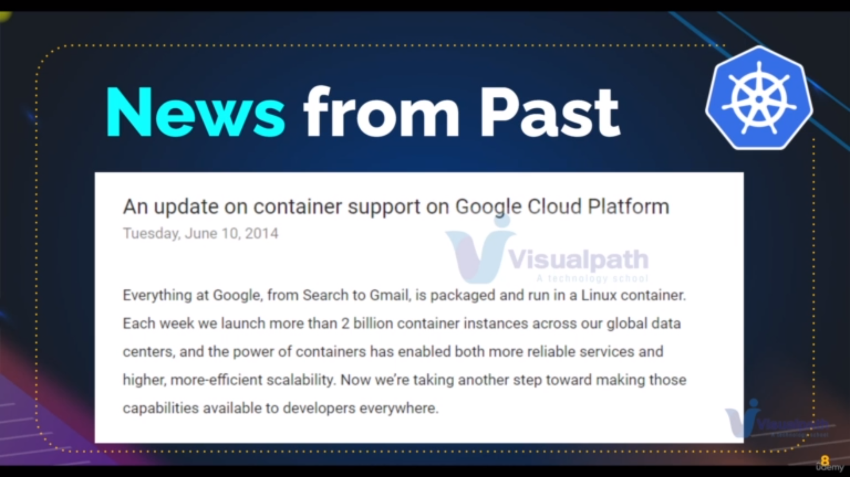it info that why google create k8s tool

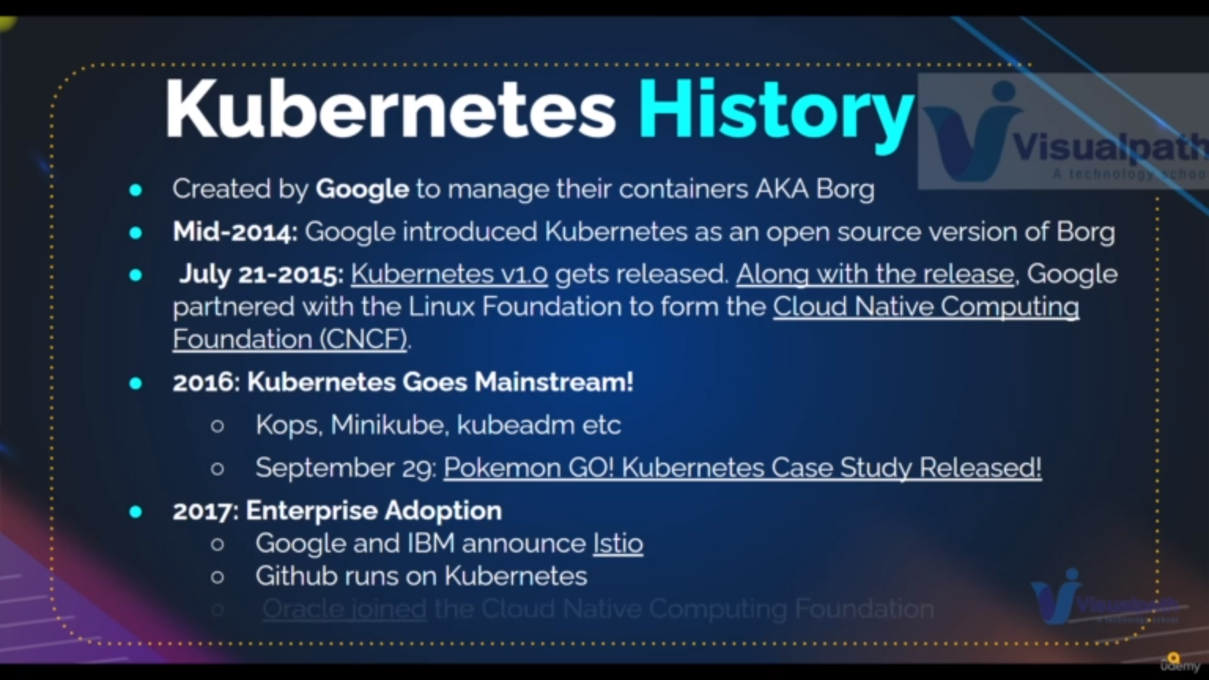history of k8s

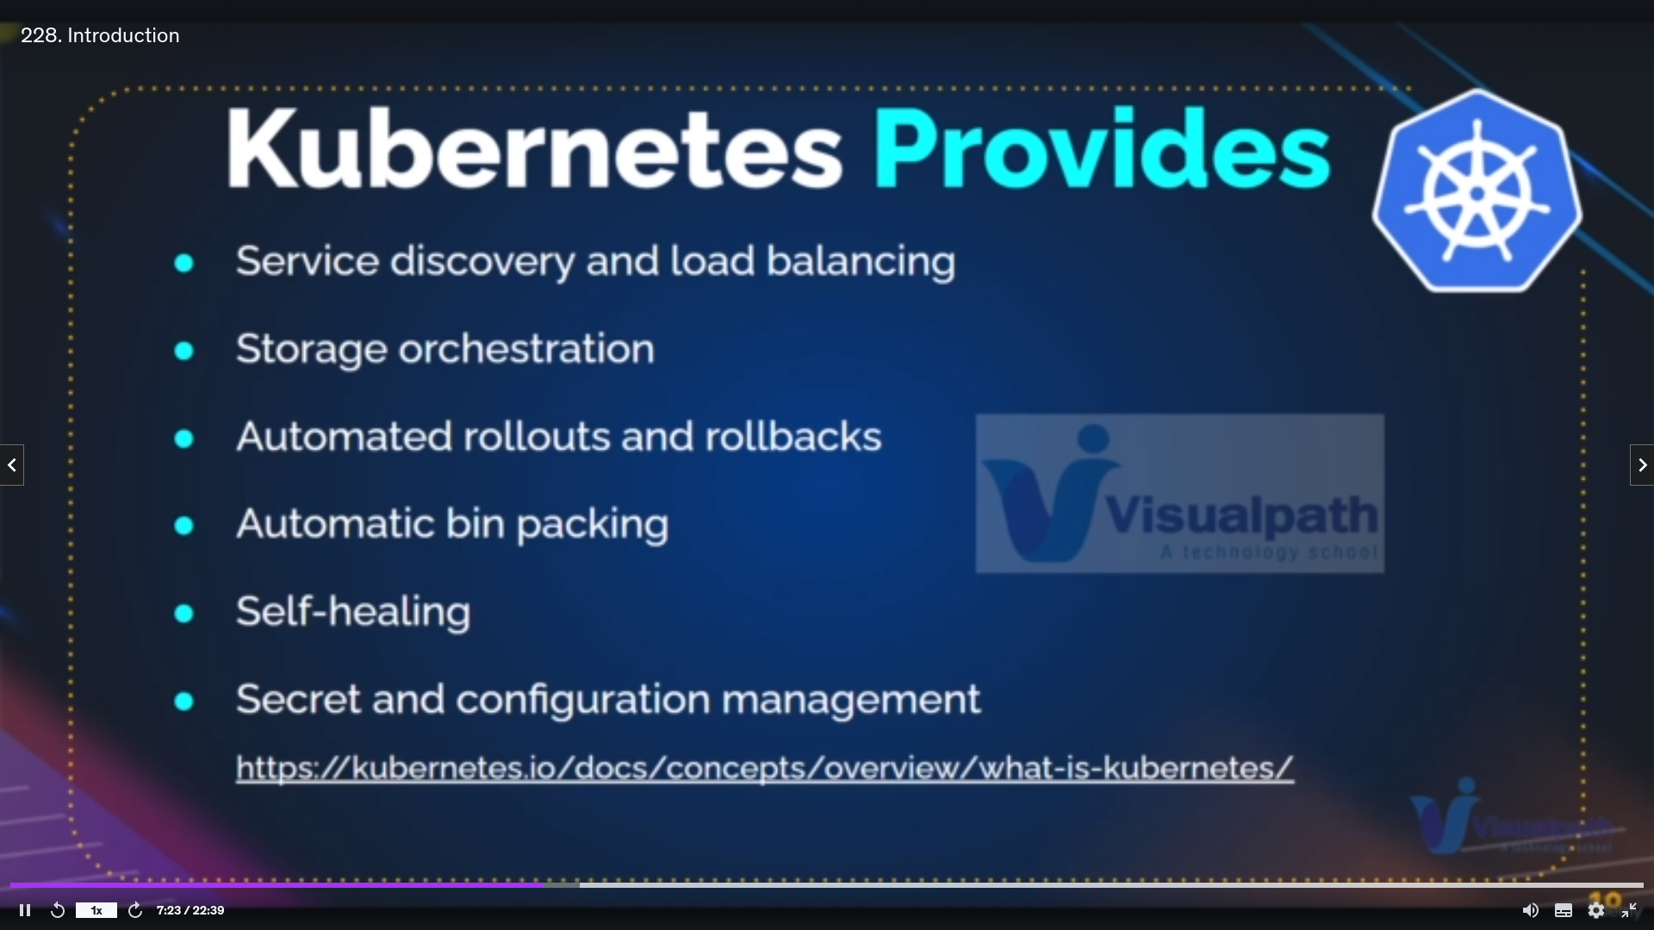advantages of using k8s

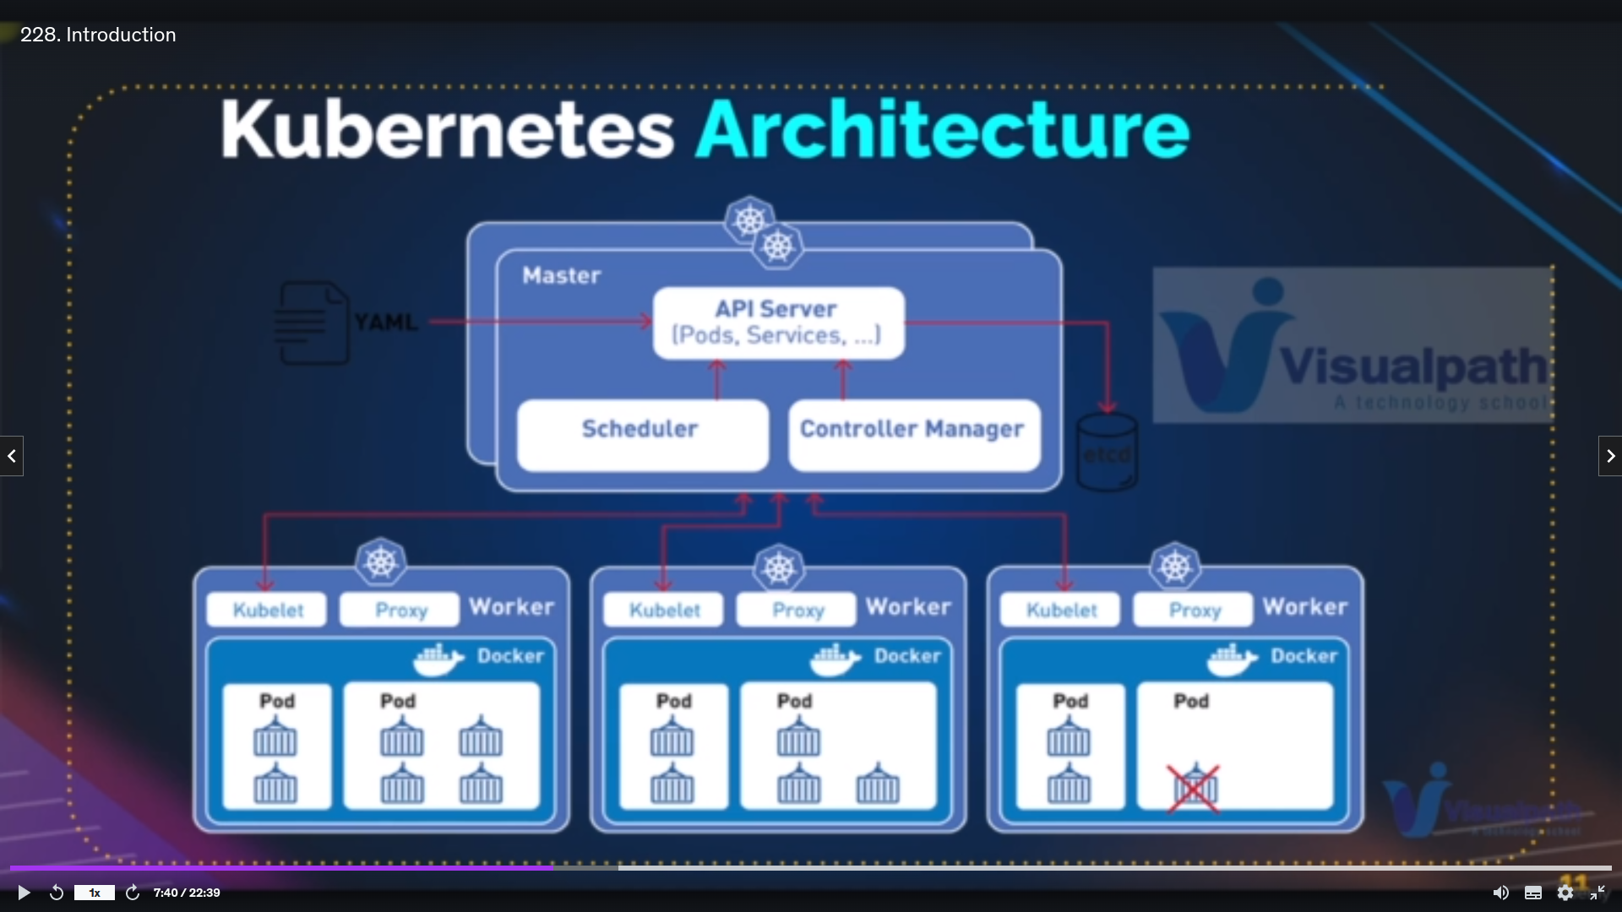Archeteure of k8s: basically what are the services provided by the k8s user explained in below images

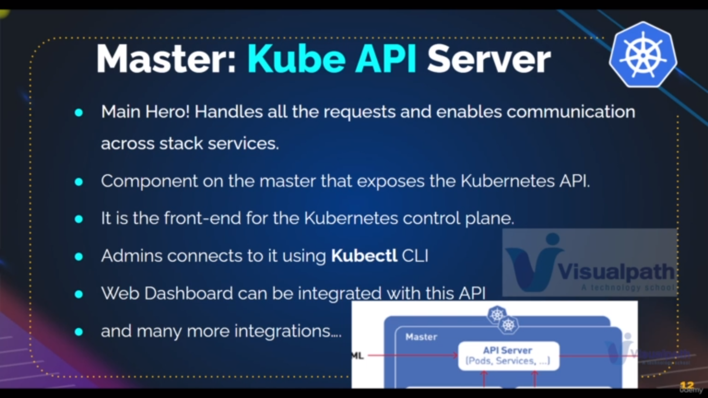**first service:Kube API Server**

it is used for commuincation between us and k8s cluster where we can communicate using **kubectl** or it is used to excuete the commands that we passed through **kubectl ex:kubectl get pods**

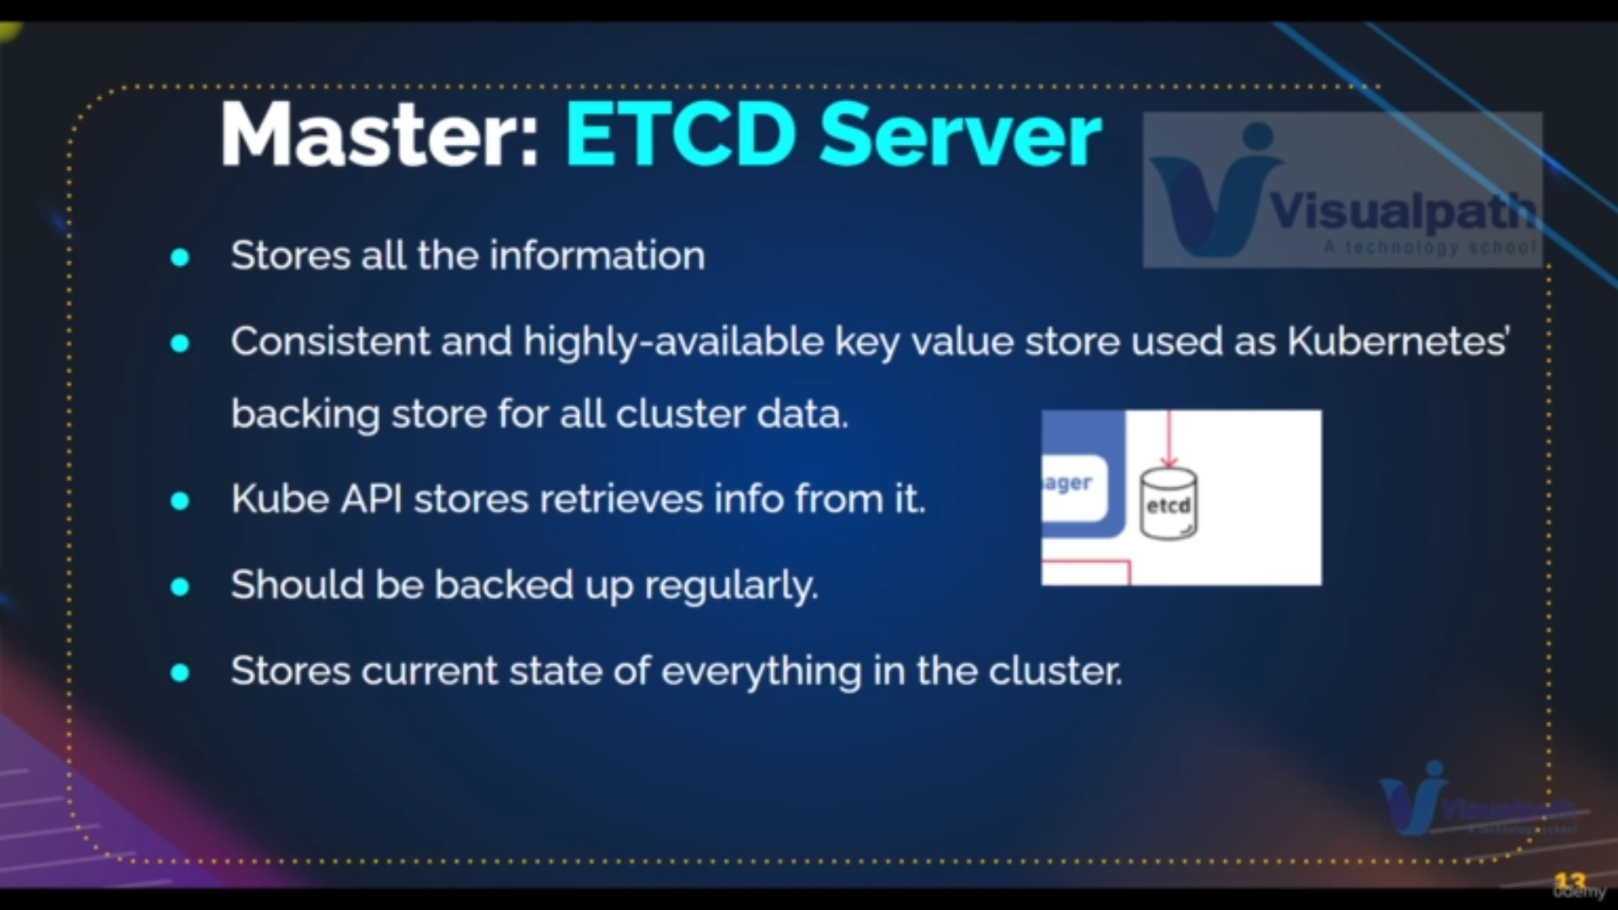**secondservice: ETCD server**

it stores all the information of pods and k8s cluster and give it to the API server

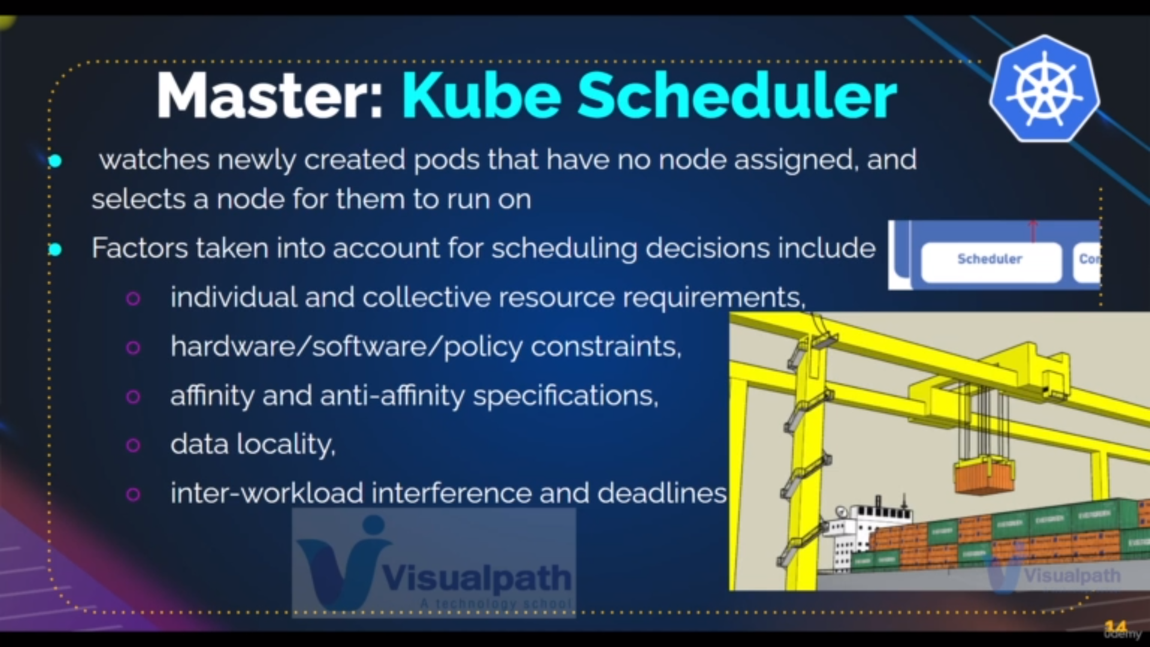**third service:Scheduler**

it is used to decide to launch the pod in which agent when api server excuete the user command of creating pods based on different factors

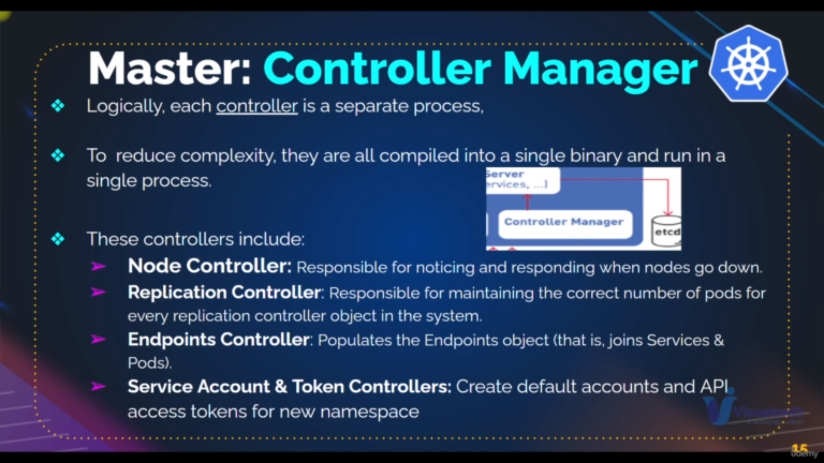**fourth service: Controller manager**

we have different services in controller manager

basucically it is used to monit0r and taker apporpriate action on pods

ex: auto replication [refer above image for details]

**Basically These are the services that are there in master node**

**Below are the services that are there in the slave node**

we can also add the various tools to get various services that there are

there in add on page [below second image]

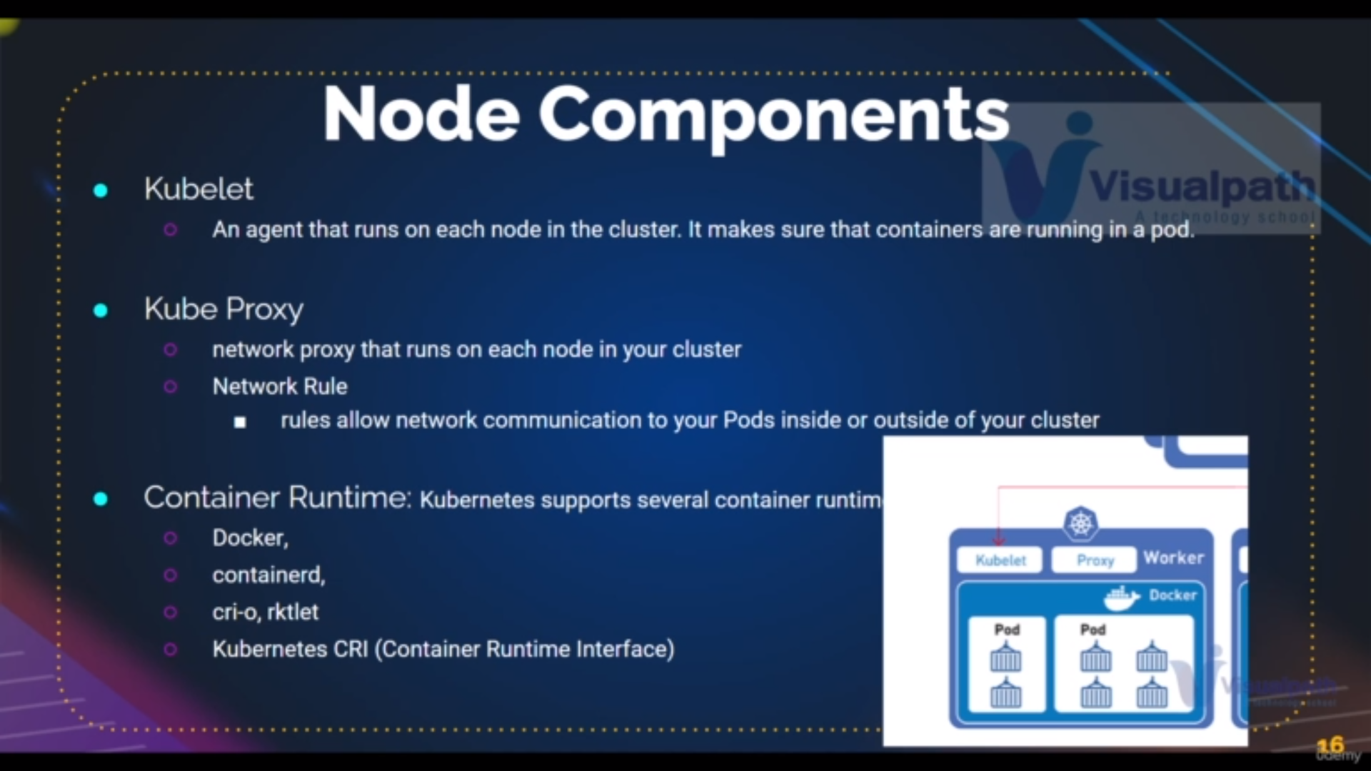**Kubelet** :it is the agent which is there for communication b/w master and slave nodeand moniter the pods

**kube proxy :** is used to connect to intenret

**container run time :**container used to run the containers in pods

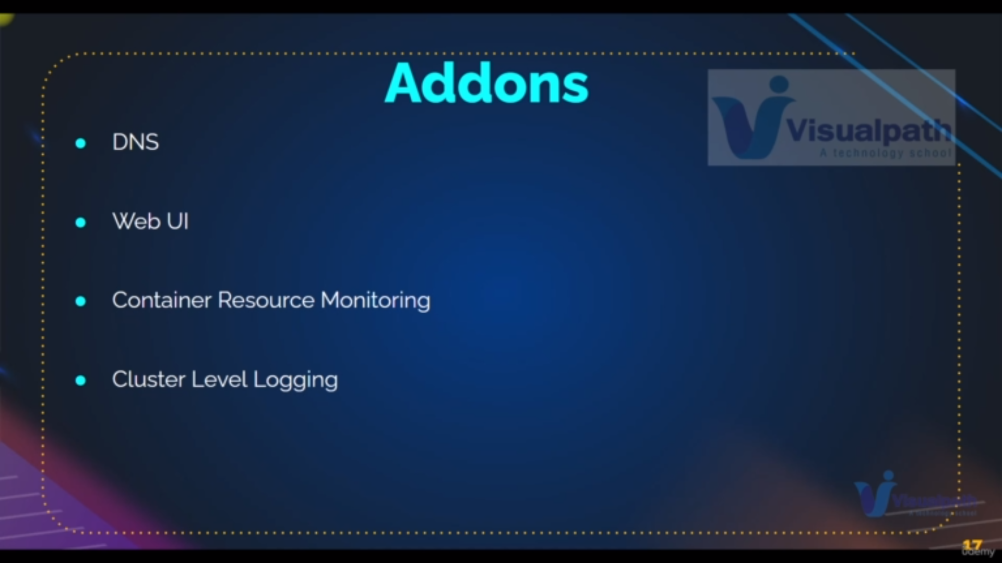

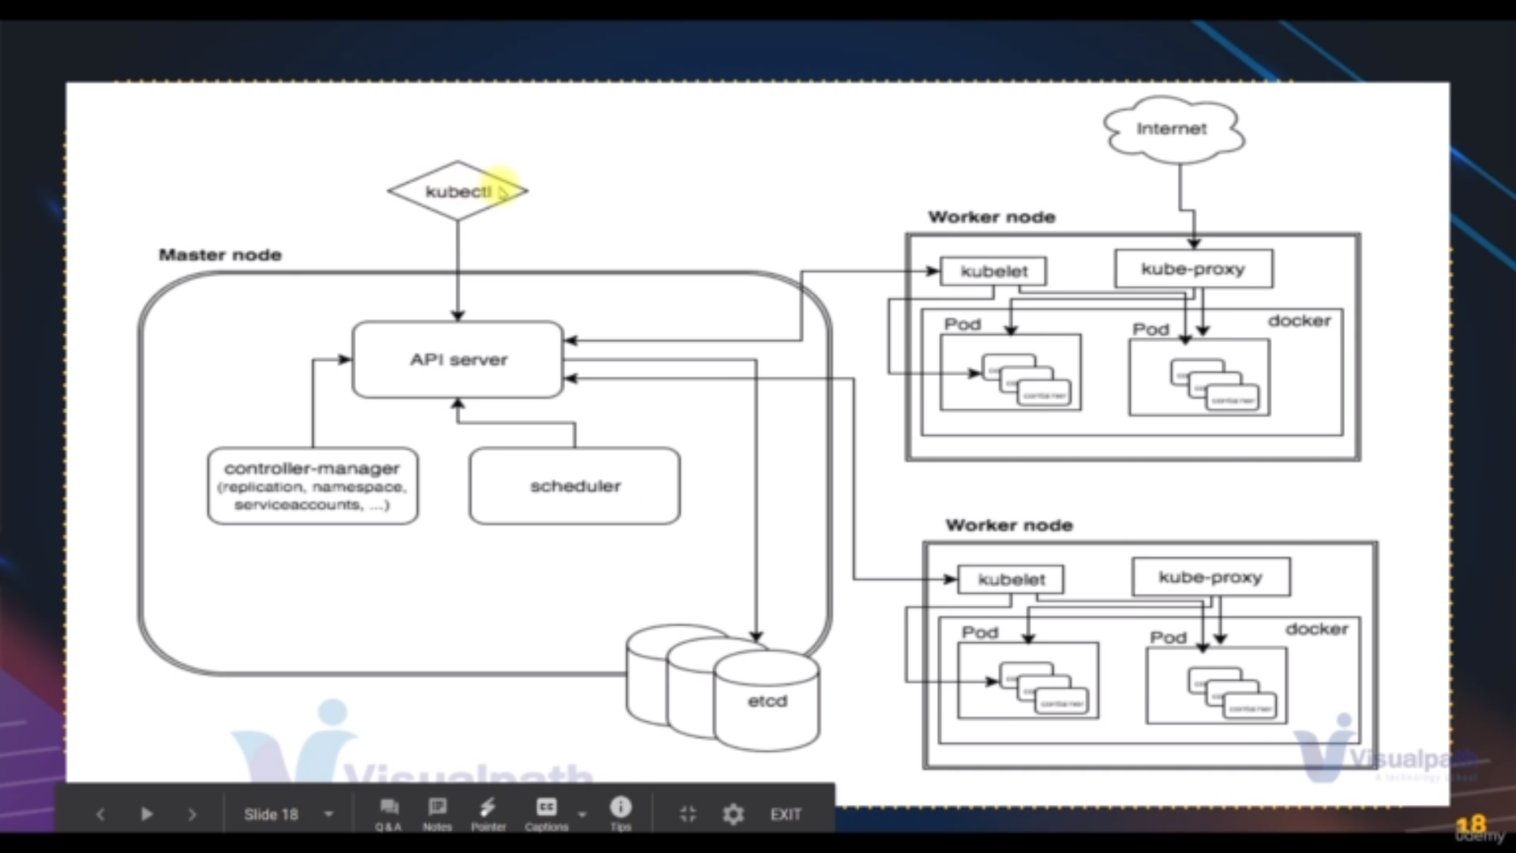

true architecture of k8s what services what will do

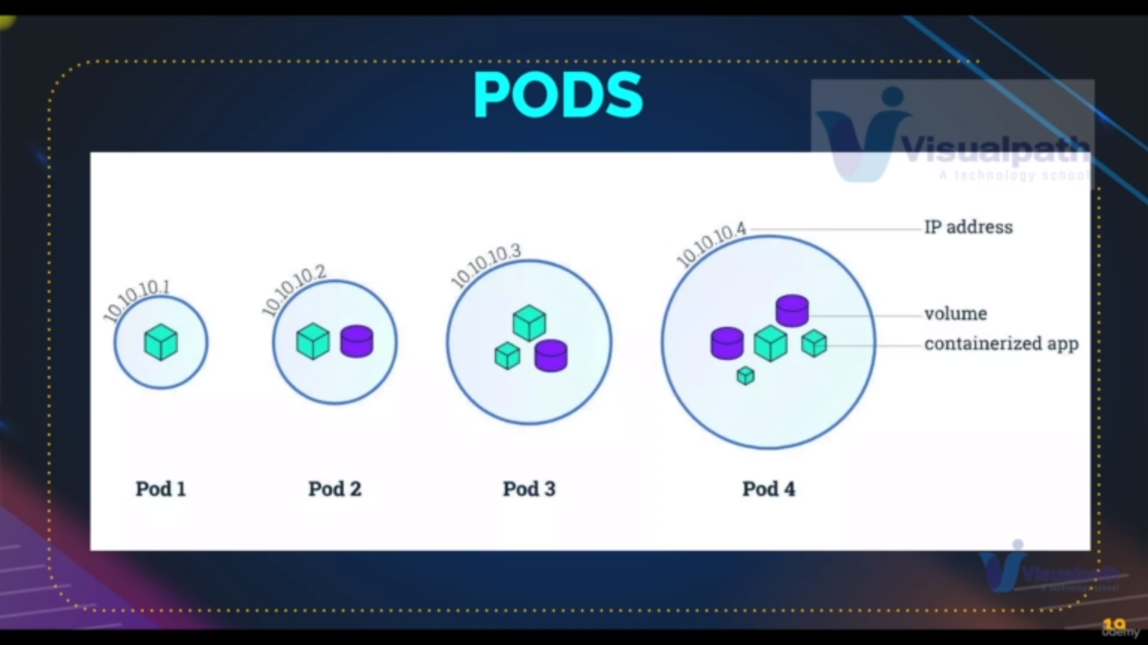pods vs containers: In pods we can user multiple container and it is created for abstraction

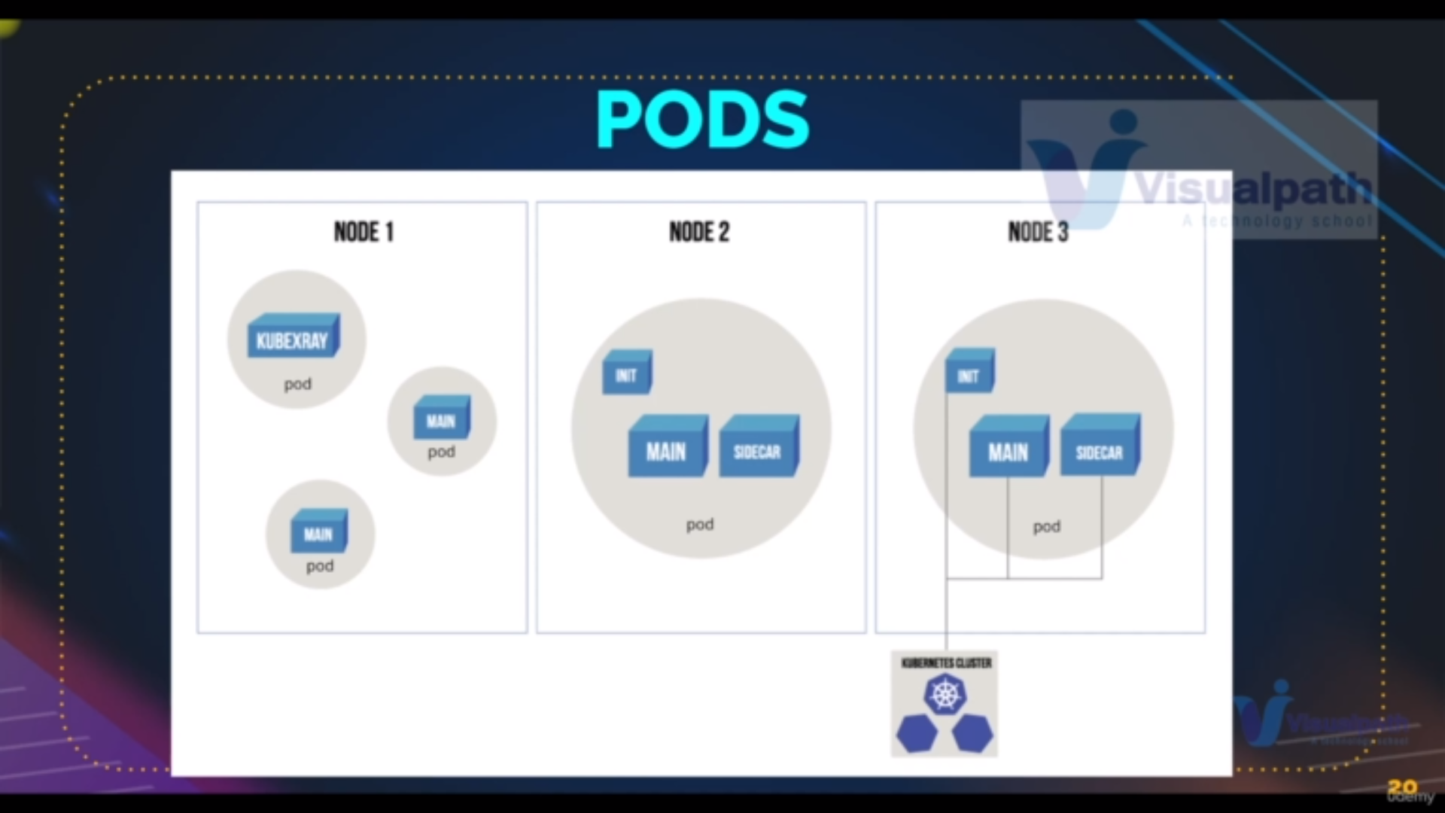Generally we have one container one pod concept only . if we need helper container then we have one pod two container . here we use side car is used to moniter the logs main container

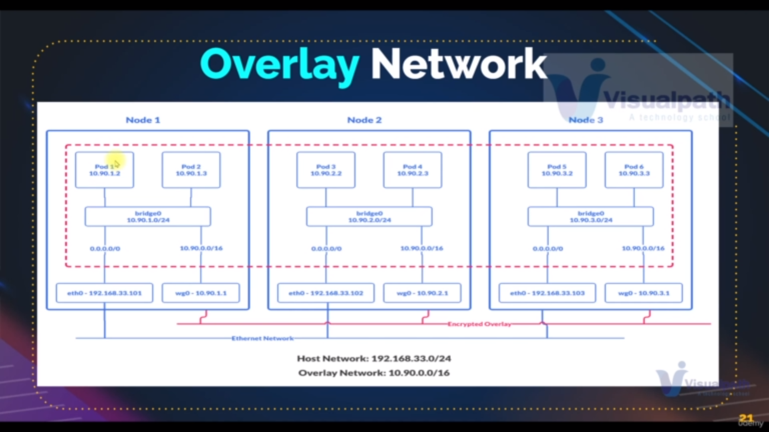pod1 to pod6 communication

pod1→ bridge→ wg0[node1]→ wg0[node3]→ bridge→ pod6

instance1→ switch→ router[node1]→ router[node3]→ switch→ instance6

**Setup for kubernetes:**

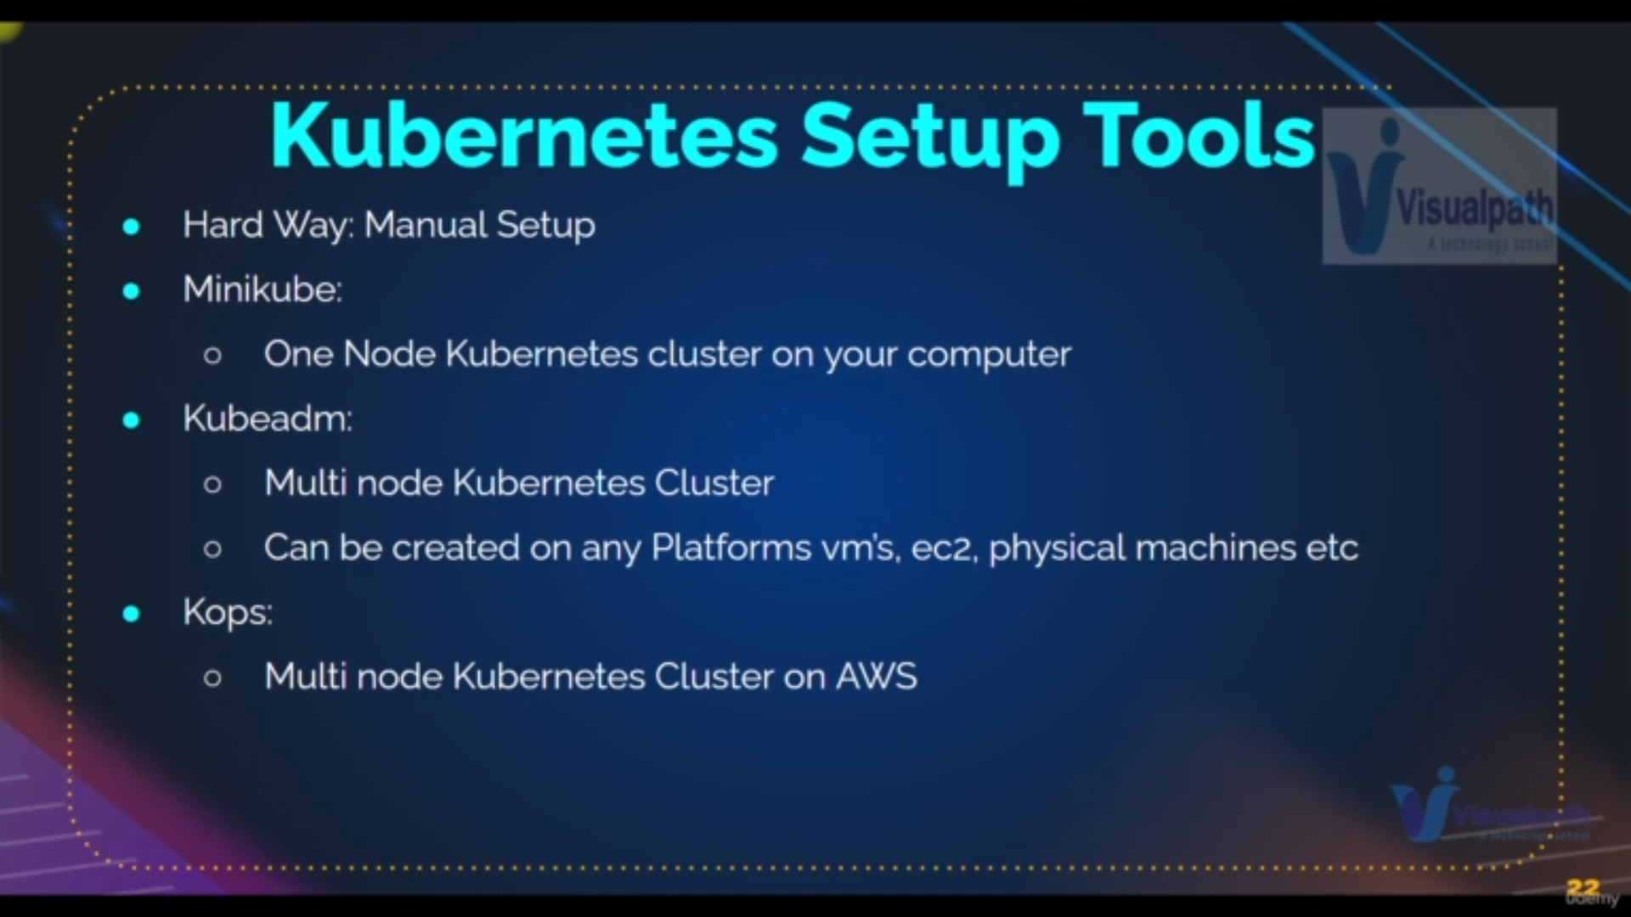this will be done after sometime

**kubeconfig file:**

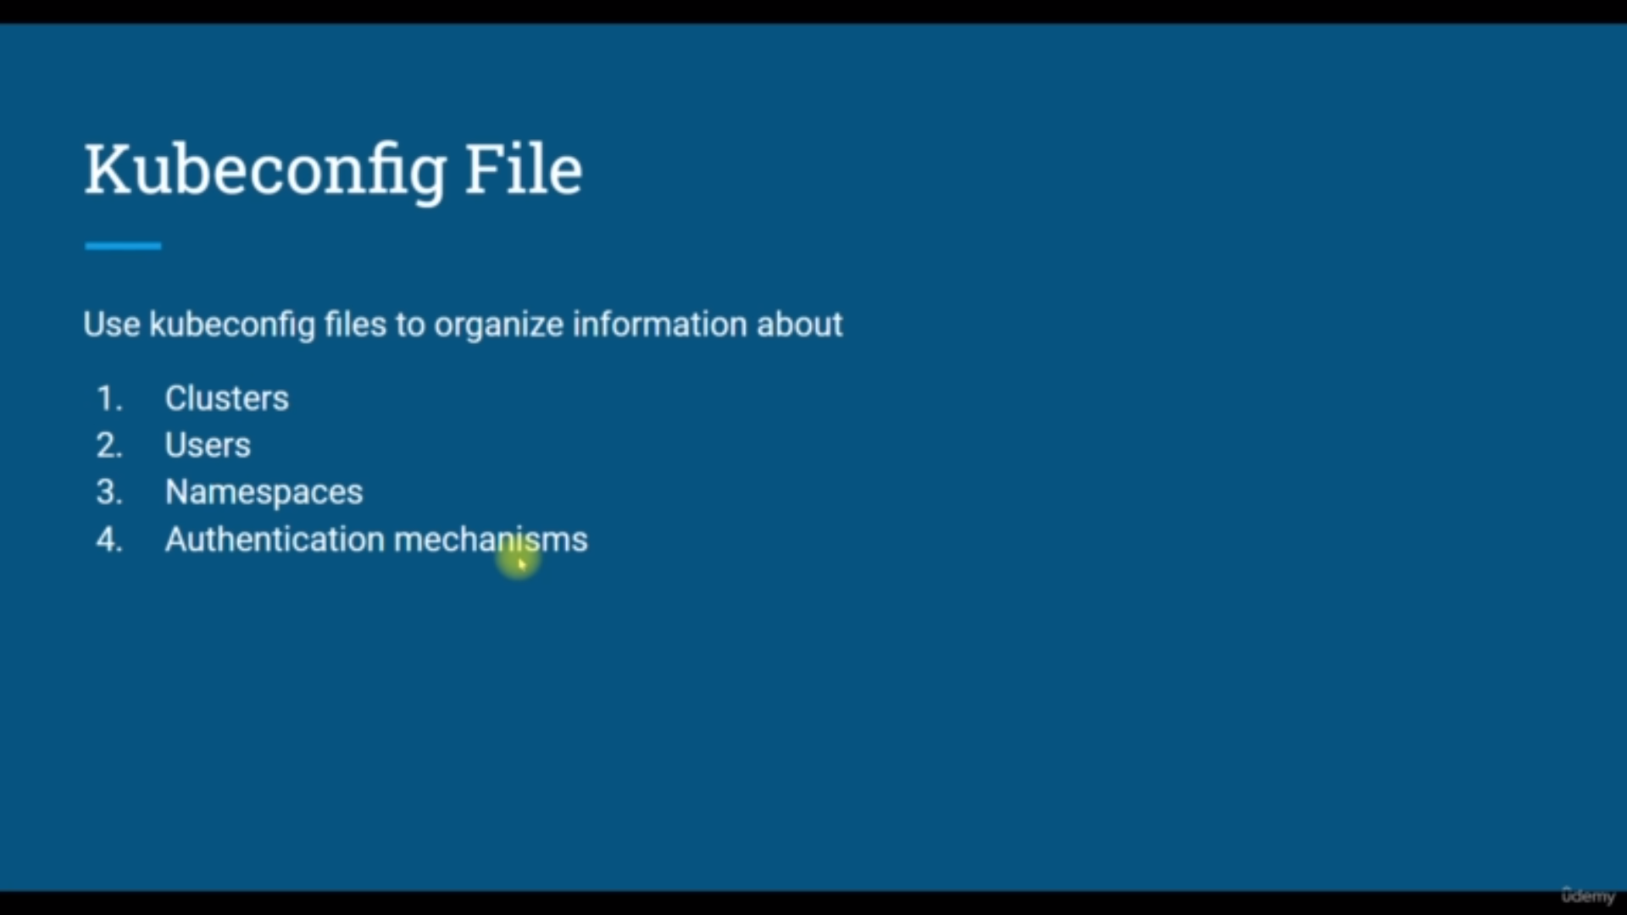

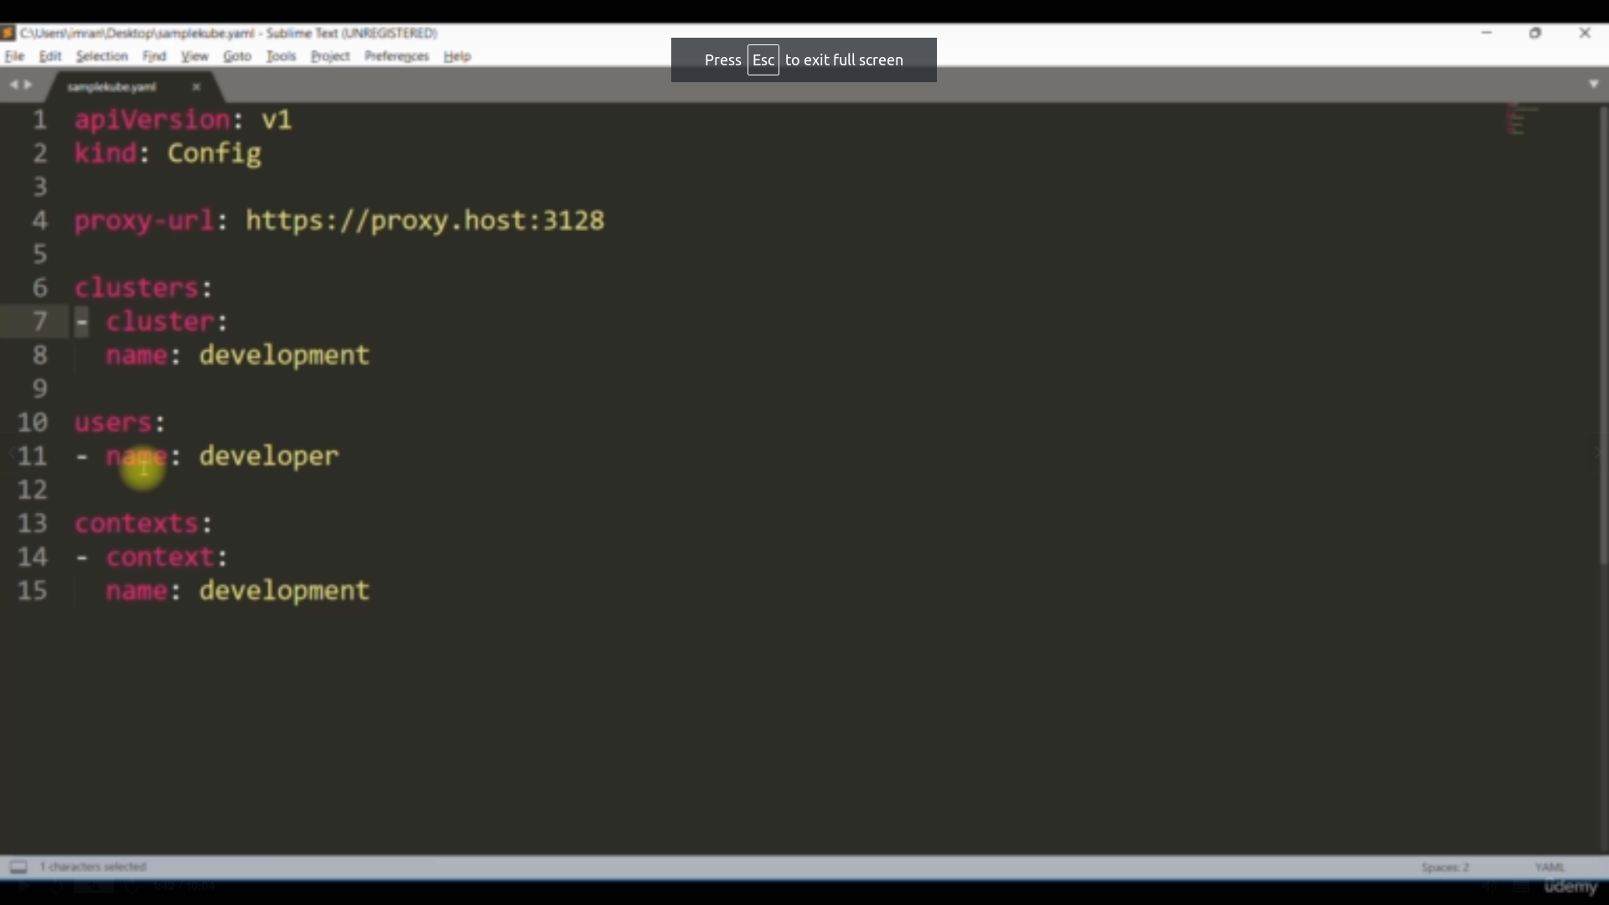demo of /home/.kube/config

In the config file

we have three main parts information

**cluster info:** here we have the cluster certificate and all cluster related information

**user info**: here we have the user information and user certificate

**context info**: here we have context information means which is user is connected to the which cluster and

current context information [on which cluster that kubctl command works]

**Command1:**

**--------------------------------------------------**

**kubectl config view**

**-------------------------------------------------**

**explanation:**

it will show the config file in readable format

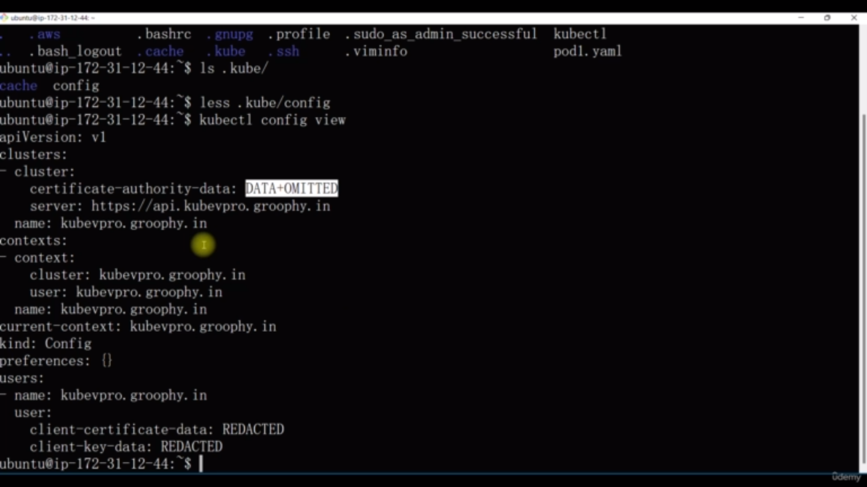**command**1

**Note**: if we cut and copy the config file to another instance

it will works from there also

**NameSpace:**

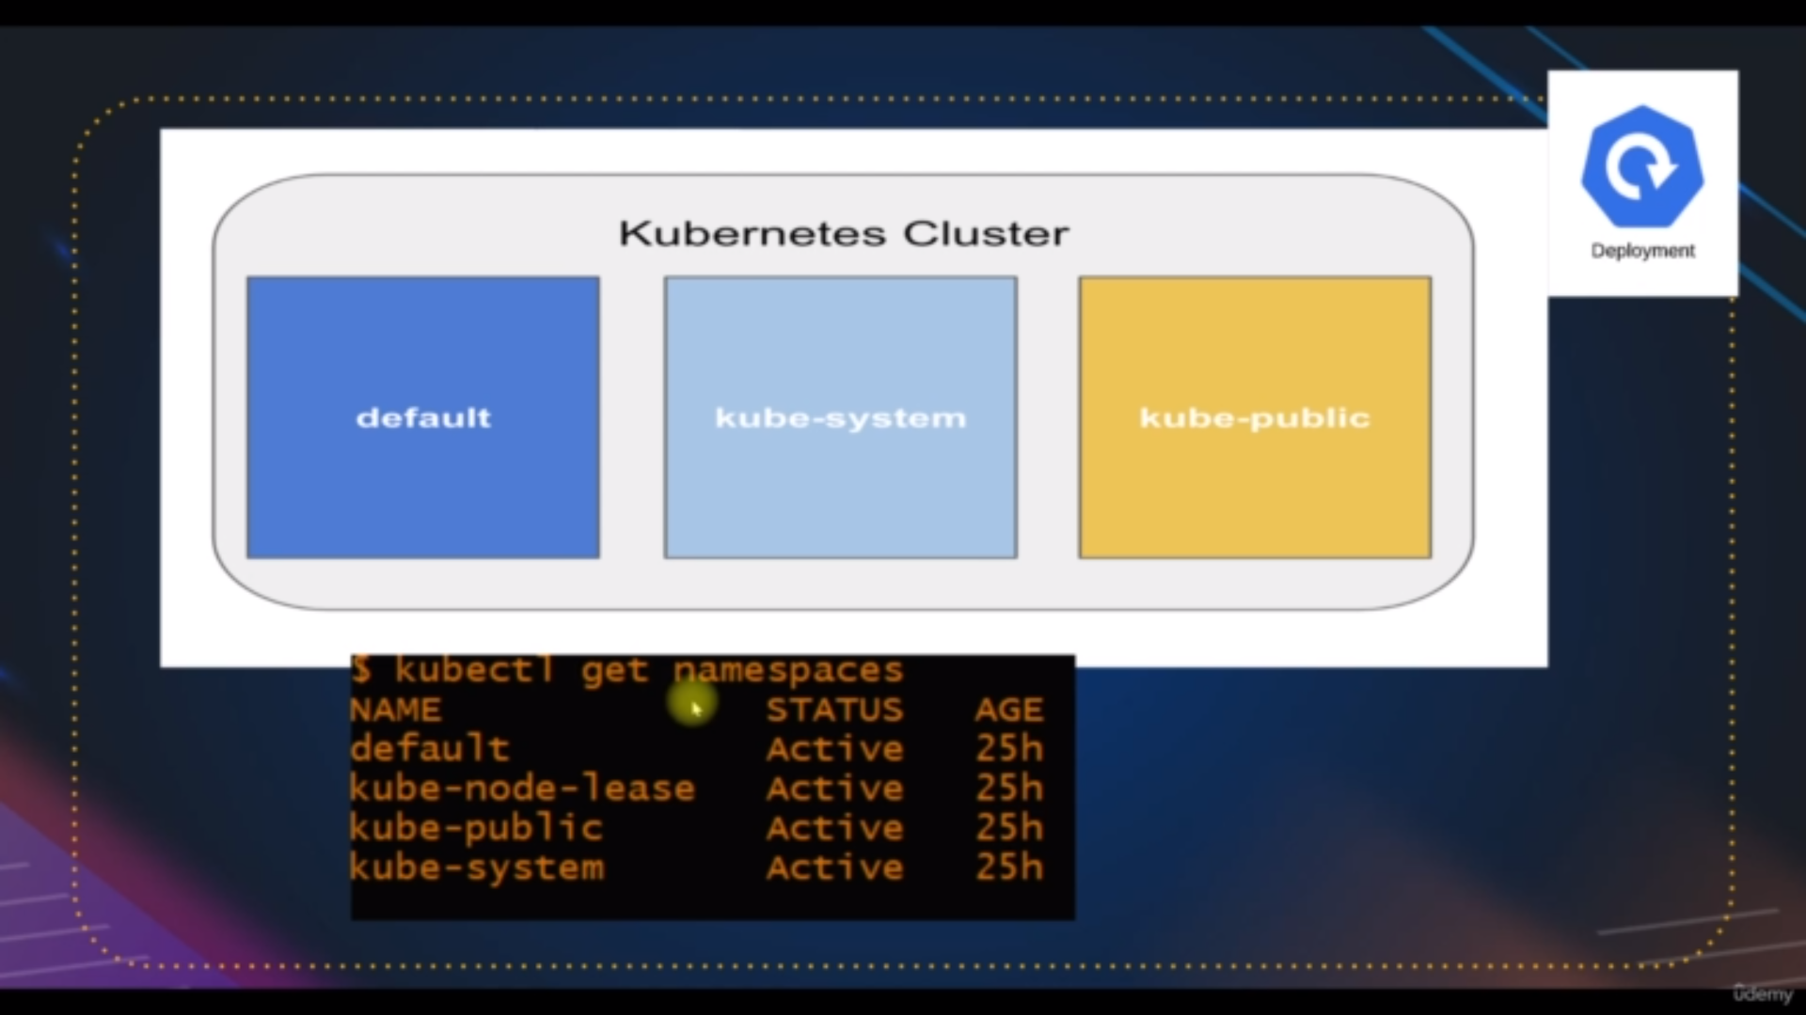default namespaces

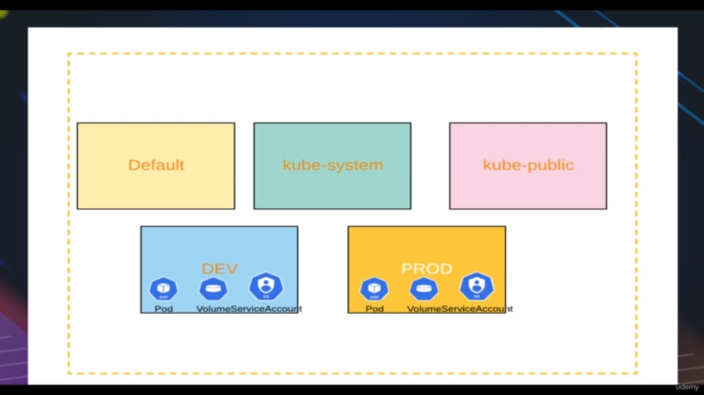we can create our own namespaces

Name space is mainly used for

1) **filtering:** [where we can easily search the pods when we its Namespace]

2)**ambiguity:** [we cannot create pod with similar name in same namepsace

but we can create in different name space]

3) **easy deletion**: [deleting namespace the entire pods and all services

will be deleted]

**Commands:**

**command2:**to show all the namespaces

**----------------------------------------**

**kubectl get ns**

**-----------------------------------**

**command3:**to show all the object in default namespace

**----------------------------------------**

**kubectl get all**

**-----------------------------------**

**command4:** to show all the object from all namespaces

**----------------------------------------**

**kubectl get all --all-namspaces**

**-----------------------------------**

**command5:** to show all the object from particular namespaces

**----------------------------------------**

**kubectl get svc -n [namespace name]**

**-----------------------------------**

**command 6:** to create the namespace

**----------------------------------------**

**kubectl create ns [namespace name]**

-----------------------------------

**command 6:** to create the pod in particular namespace

**-------------------------------------------------------------------------------------**

**kubectl run [podname] --image=nginx -n [namespace name]**

------------------------------------------------------------------------------------

**command 7:** to run the yaml which has the details of creating the

kubenetes objects

**-------------------------------------------------------------------------------------**

**kubectl apply -f [filename.yaml]**

------------------------------------------------------------------------------------

example of yaml filename

-------------------------------------------------------

apiVersion:v1

Kind: pod

metadata:

name: podname

namespace: namesapcename

spec:

containers:

- name : containername

image: nginx

ports:

- containerport : 80

-----------------------------------------------------------------------------------

**command 8:** to delete the namespace

**-------------------------------------------------------------------------------------**

**kubectl delete ns [namespacename]**

------------------------------------------------------------------------------------

**kubernetes objects:**

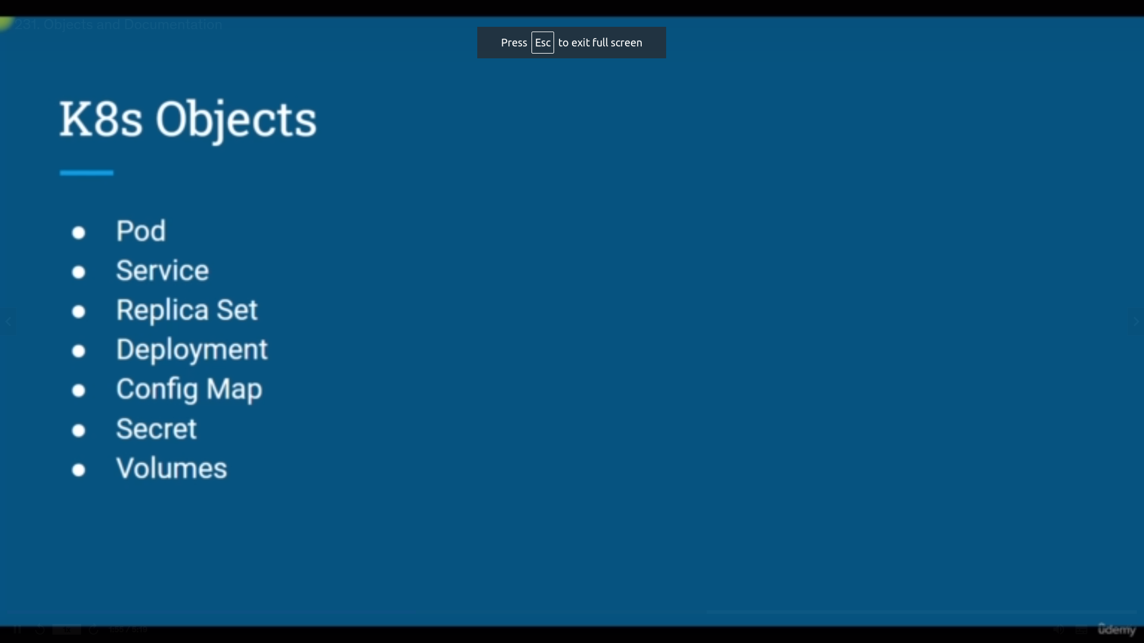pic 1

**pod[object1]:**

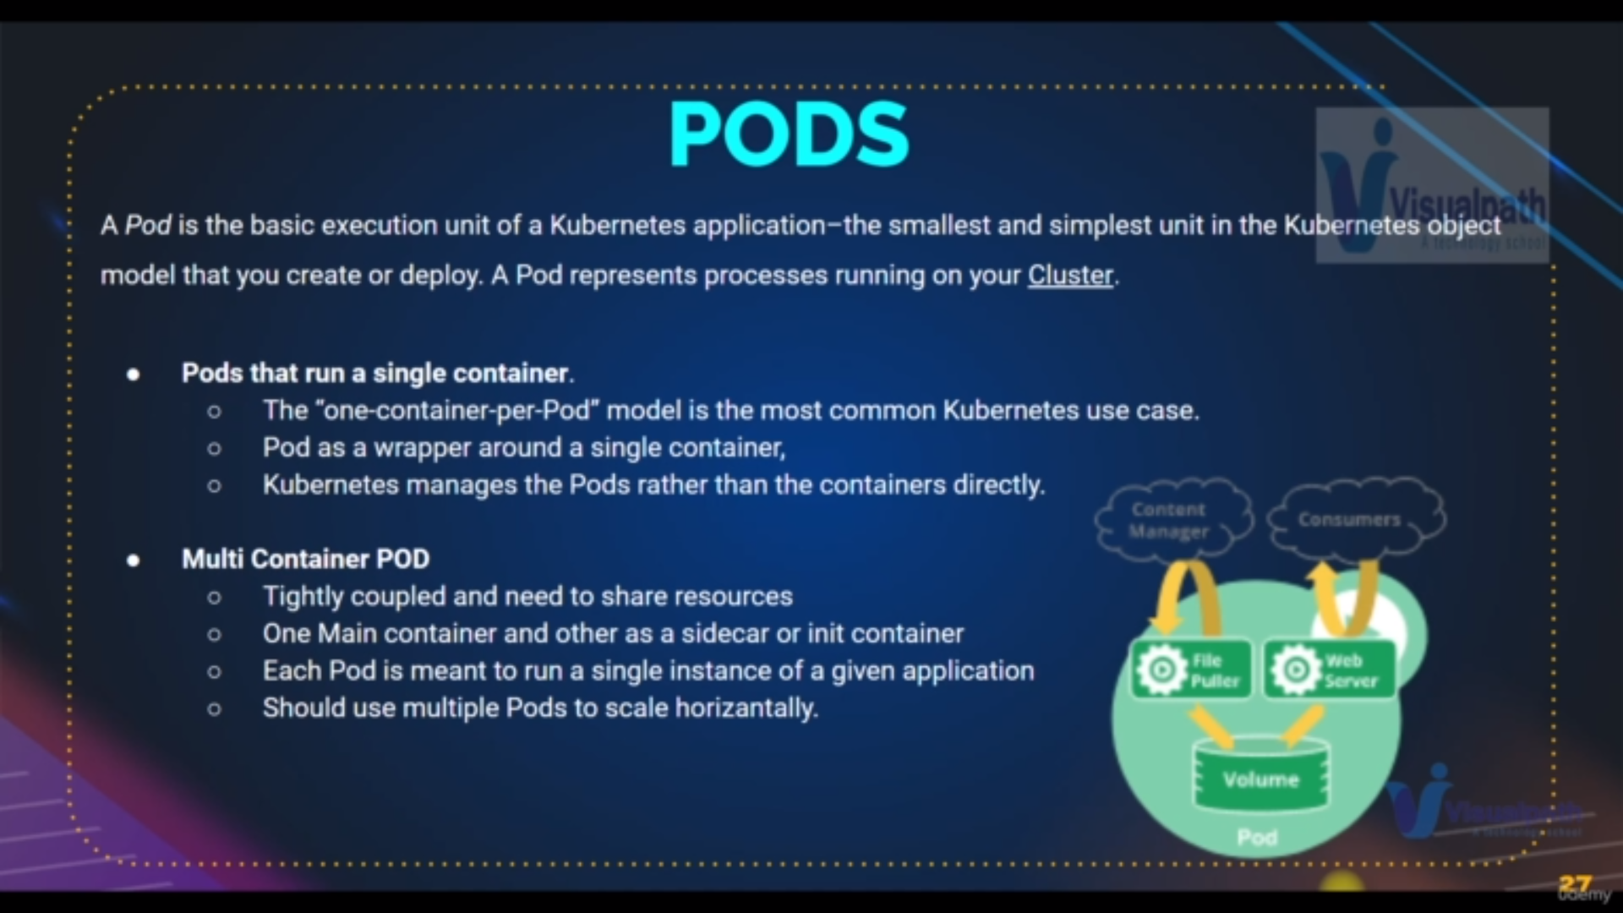pods definnition

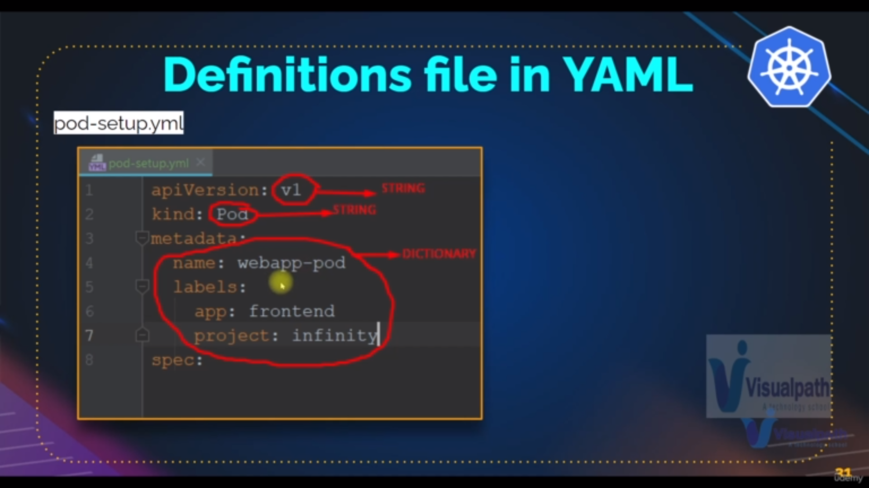

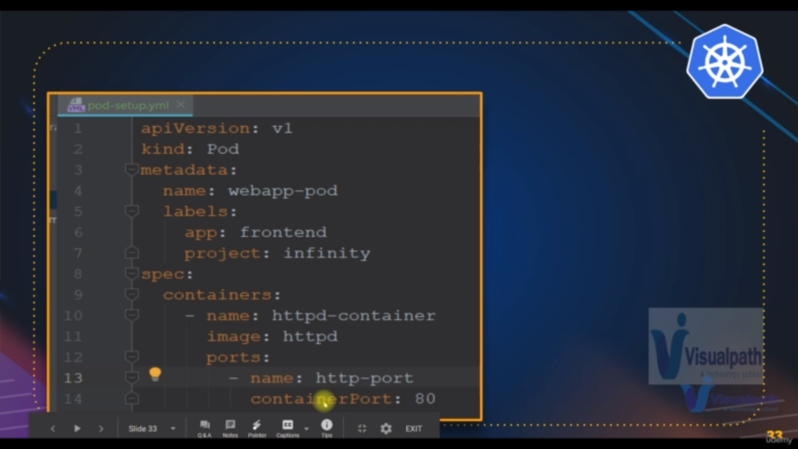spec containes : container details or techinical details for pod

metadata contains normal details for pod

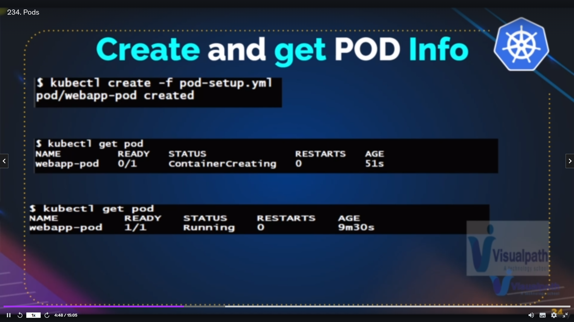

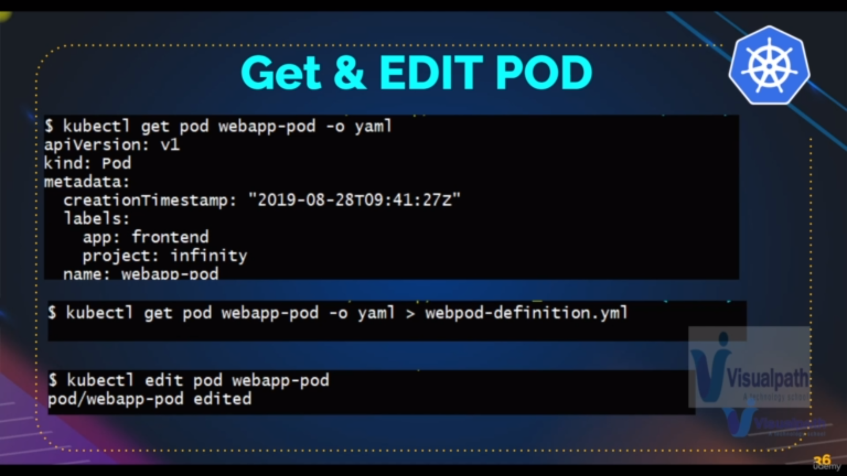pod commands .

**Commands:**

**Commands9:** to get the details of master and slave nodes

**---------------------------------------------------------**

**kubectl get nodes**

**--------------------------------------------------------**

**Commands10:** to get the full details of single node

**---------------------------------------------------------**

**kubectl describle node [nodename]**

**--------------------------------------------------------**

**Commands11:** to get the full details of single node inf yaml format

**---------------------------------------------------------**

**kubectl get node [nodname] -o yaml**

**--------------------------------------------------------**

**Commands12:** to run the yaml file to create pod

**---------------------------------------------------------**

**kubectl create -f [filename.yaml]**

**--------------------------------------------------------**

**_______________________________________________________________________**

**apiVersion:v1**

**Kind: pod**

**metadata:**

**name: pod1**

**lables:**

**name:**

**app: app1**

**project : p1**

**spec:**

**Containers:**

**- name: c1**

**image: image**

**ports:**

**- name : portname**

**container port : 8080**

**_____________________________________________________________________________________**

**Commands13:** to get the full details of single pod

**--------------------------------------------------------**

**kubectl describle pod [podname]**

**--------------------------------------------------------**

**Note: By above commands you will get the events where we see the steps for creating the pod**

**Commands14:** to get the details of all pods

**---------------------------------------------------------**

**kubectl get pod**

**--------------------------------------------------------**

**Trouble shooting for pods:**

**a)CrashLoopBackoff:** it occurs when we do not run the command19 perfectly

**b)imagepullBackoff:** it occurs when do not give perfect image

**Commands15:** to delete the single pod

**---------------------------------------------------------**

**kubectl delete pod [podname]**

**---------------------------------------------------------**

**Commands16:** to get the full details of single pod information more

**---------------------------------------------------------**

**kubectl get pod [podname] -o wide**

**--------------------------------------------------------**

**Commands17:** to get the full details of single pod information yaml format

**---------------------------------------------------------**

**kubectl get pod [podname] -o yaml**

**--------------------------------------------------------**

**Commands18:** to get the full details of single node

**---------------------------------------------------------**

**kubectl describle pod [podname]**

**--------------------------------------------------------**

**Command19:**to get the logs[output that comes after the shell script excuted to create container in pod ]

**---------------------------------------------------------**

**kubectl logs pod [podname]**

**--------------------------------------------------------**

**Command20:**to run the pod

**---------------------------------------------------------**

**kubctl run pod1 web1 -–image-=nginx**

**---------------------------------------------------------**

if we give

kubectl run pod1 web1 -–image-=nginx [notcommand]

it will occurs **crashloopbackoff**

**Service[object2]:**

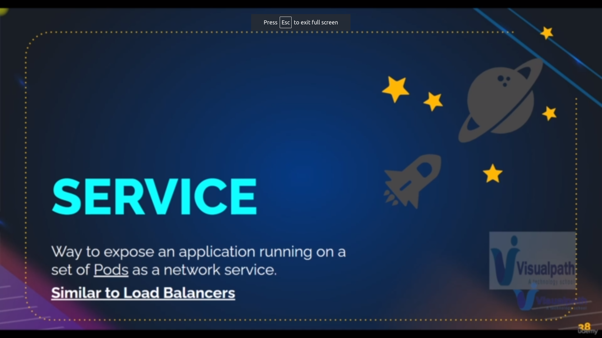

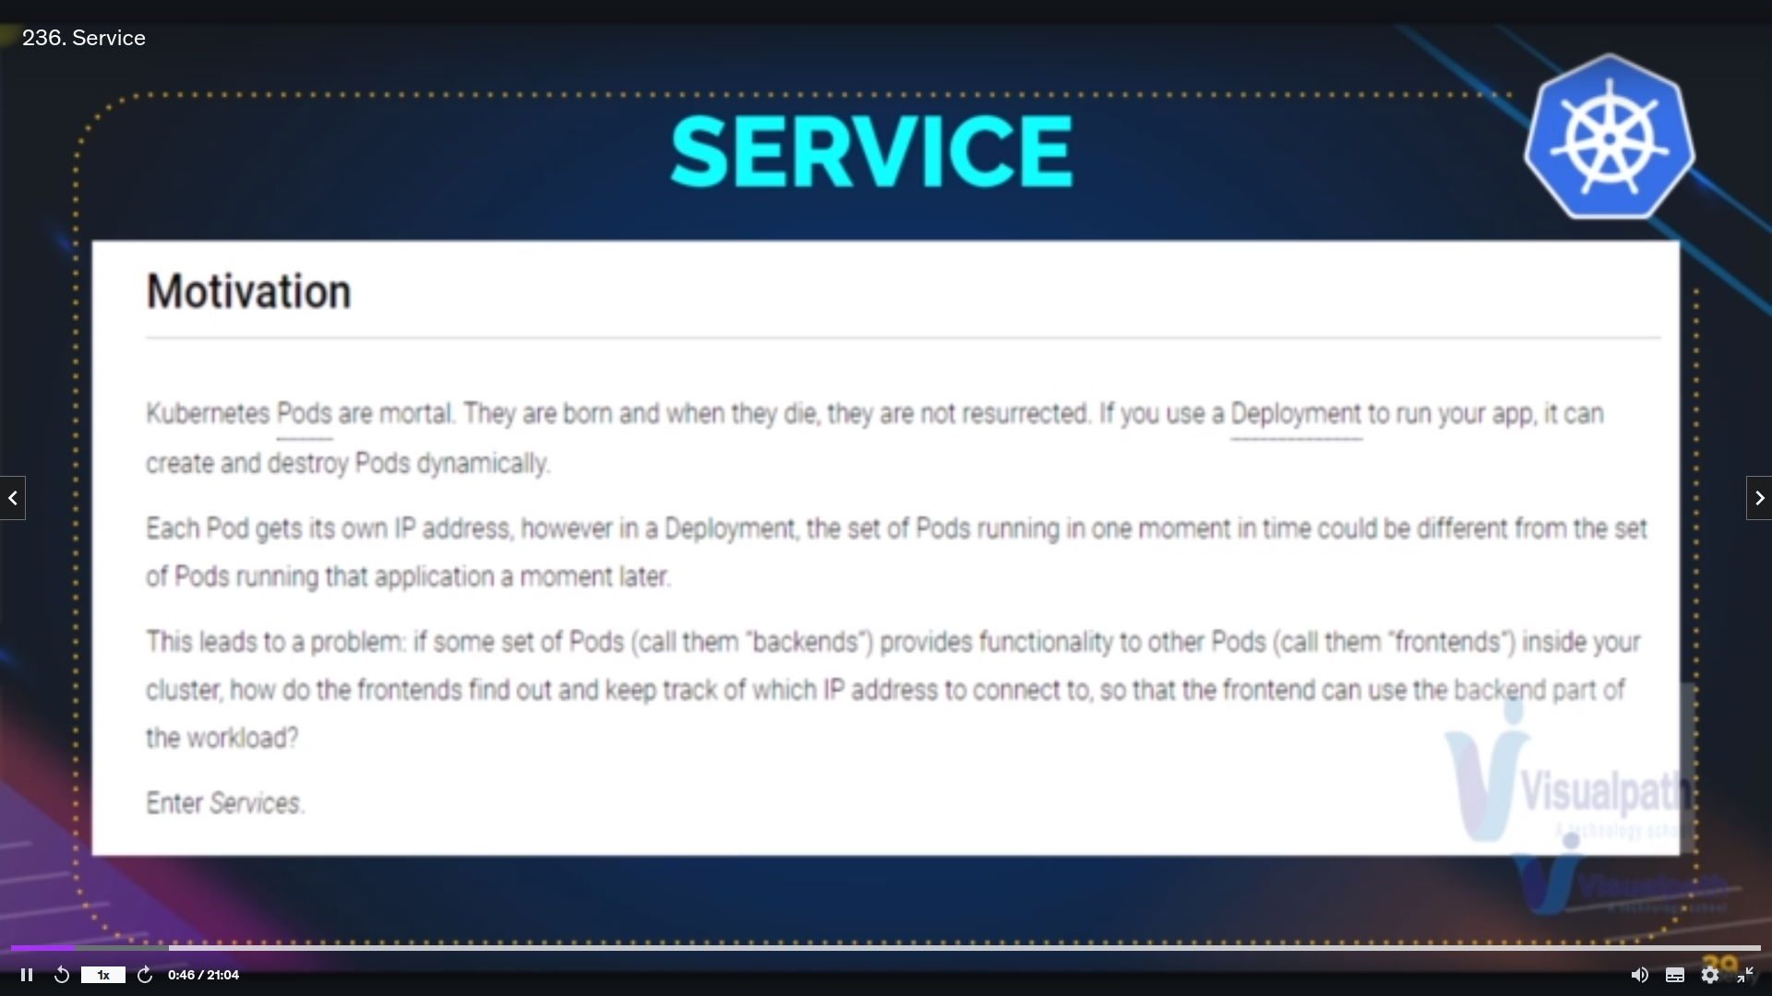why service is needed

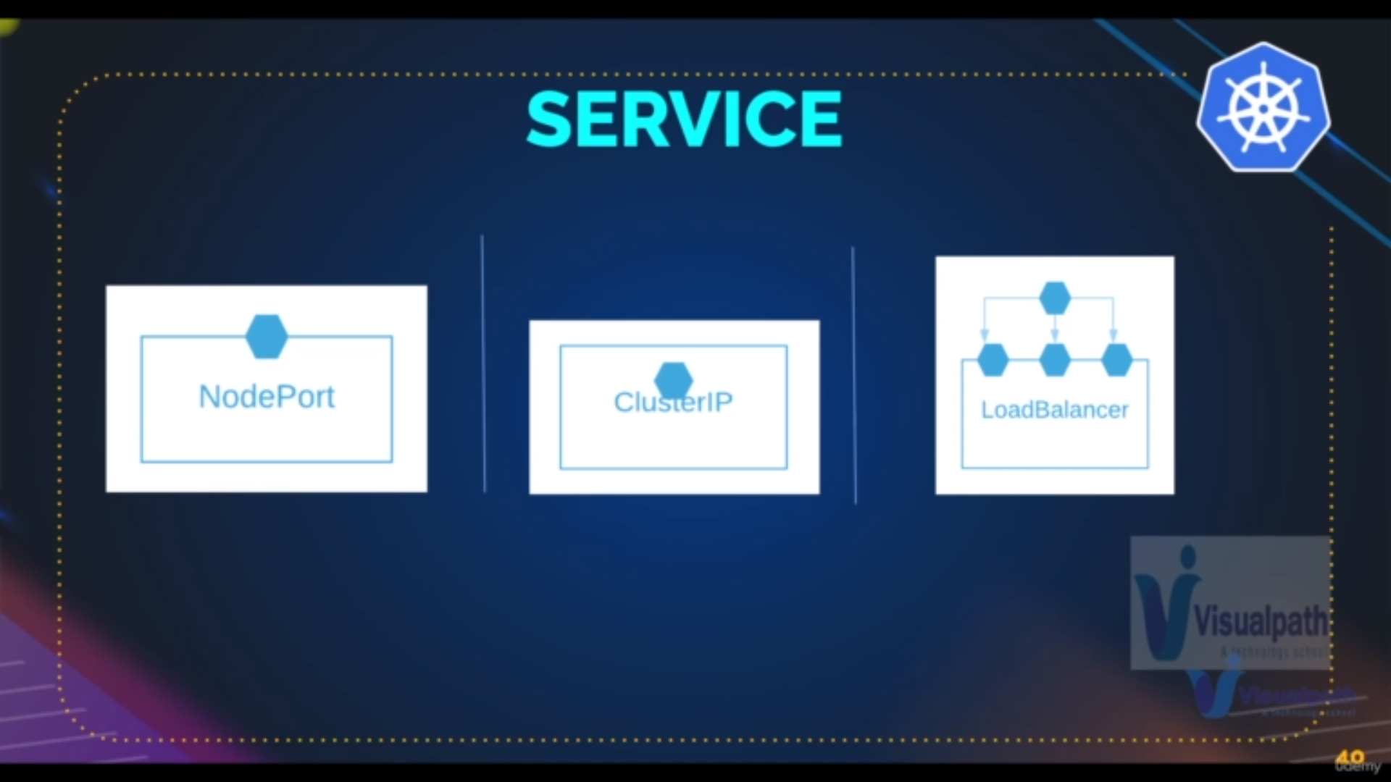Types of services

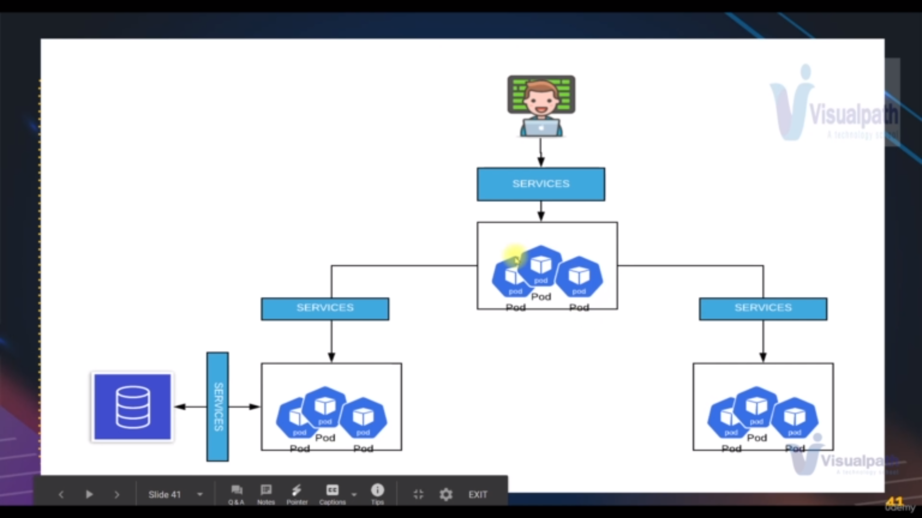working of services

**NodePort:**

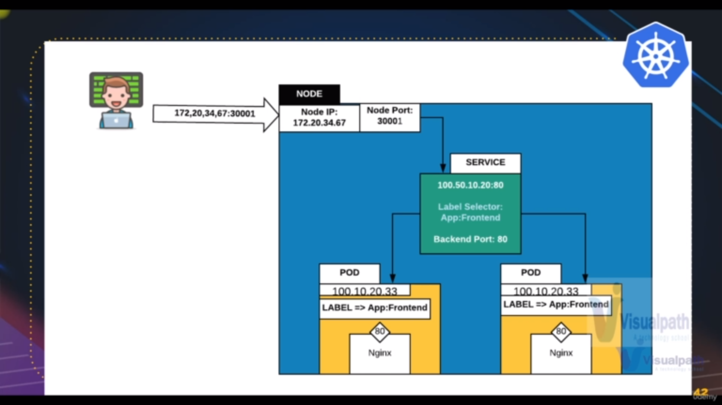Node port is attched at the frontend part of the worker node

it requires

**Node Port**: it is for outside communication [ipaddress: Nodeport]

**port**: it is the front end port of a services [communication b/w node port and service]

**target port:** it is for the backend port [communication b/w services and pods][give the port pod]

Note : But for traget port we have multiple pods with same port no so that is

why we have another filtration for to connect to particular pod which is selector

**selector**: this is for service and pod communication basically [name of the selector is what we give in the label section in metadata of pod creation yaml file]

**Command 21:** to get all services

**---------------------------------------------------------**

**kubectl get svc**

**---------------------------------------------------------**

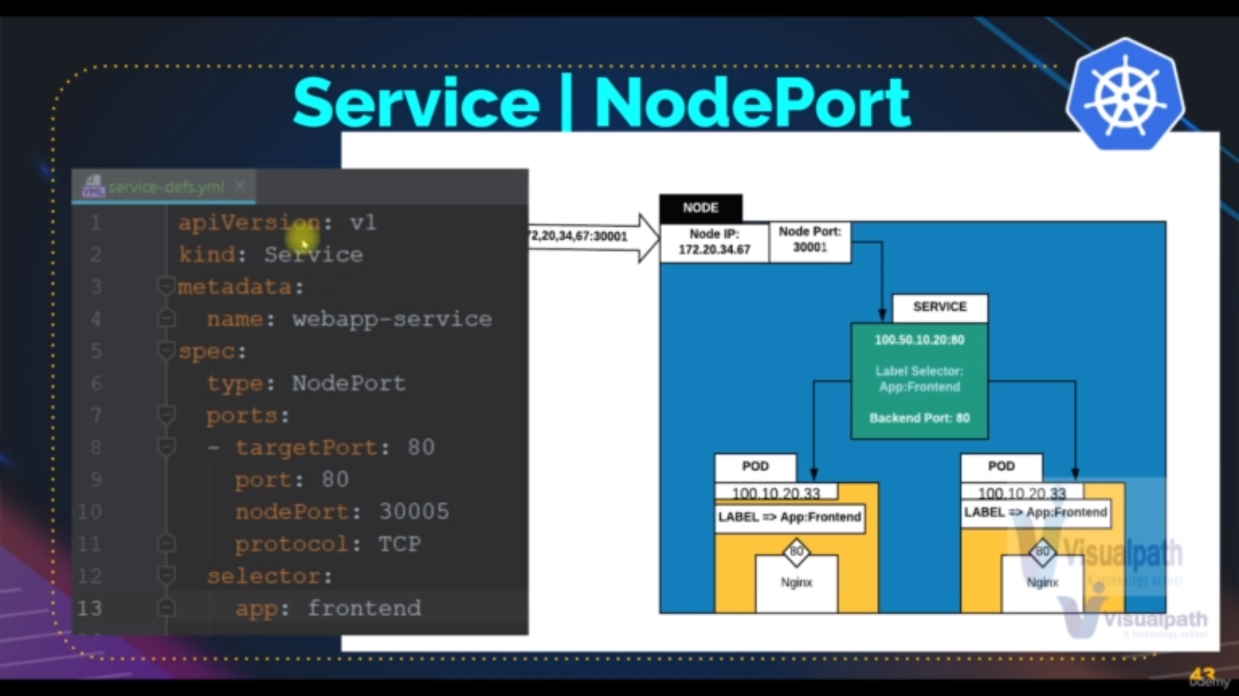

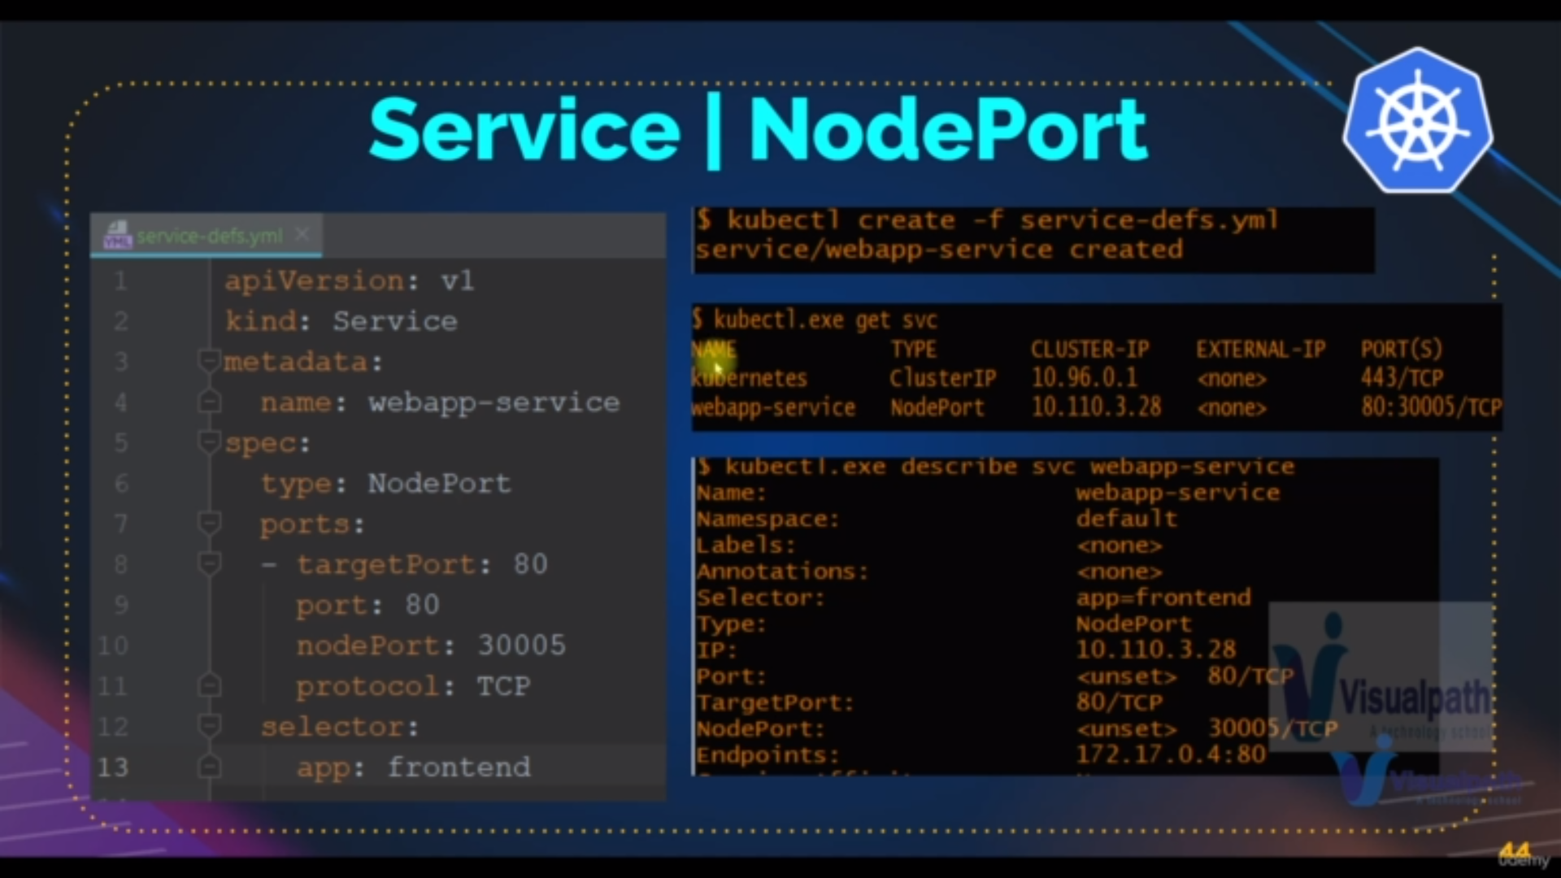Example of yaml file of service creation

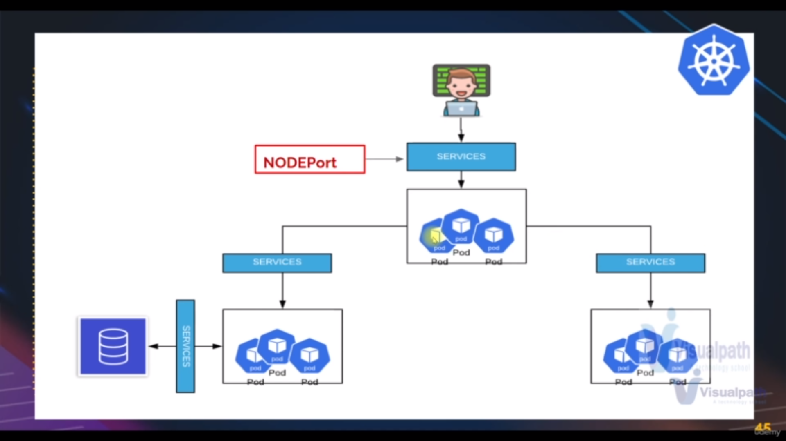flow of node ports

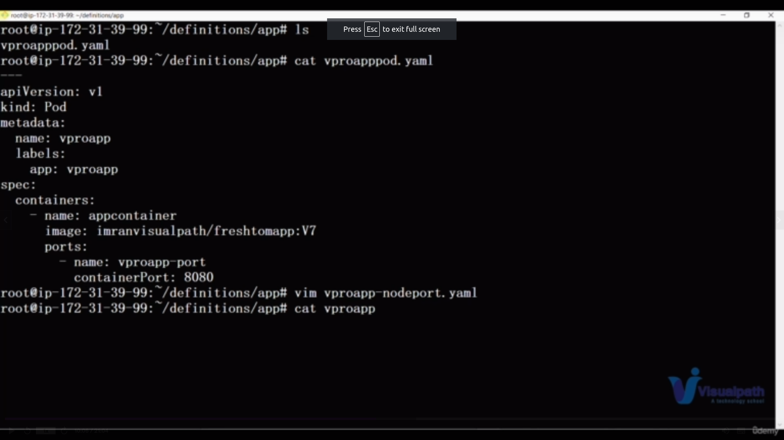**pod.yaml**

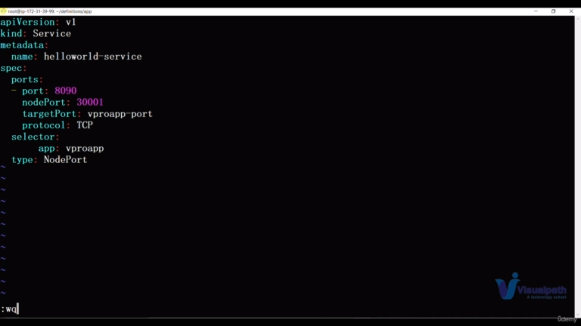**NodePort.yaml**

**Commands: referring above yaml files**

**Command 22:** to create service from yaml files

**---------------------------------------------------------**

**kubectl create -f [filename.yaml]**

**---------------------------------------------------------**

**Commands23:** to get the full details of single service

**--------------------------------------------------------**

**kubectl describle svc [svcname]**

**--------------------------------------------------------**

**Commands24:** to delete the single service

**--------------------------------------------------------**

**kubectl delete svc [svcname]**

**--------------------------------------------------------**

**LoadBalancer:**

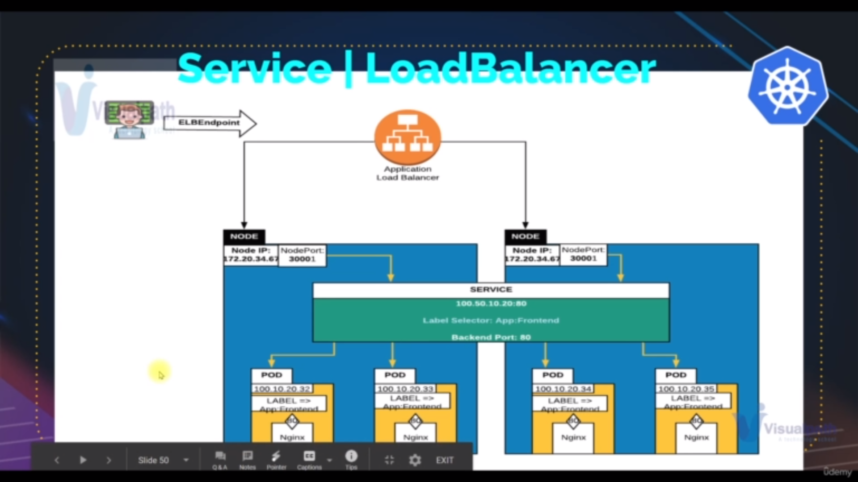load balancer is the services that is there as load balancer in aws

Requrements:

**port** : it is communication b/w outside and loadbalancer

**target port**: communication b/w load balacer and pod [through service that is there internally with in the worker node]

selector : same as Node port

Note : the node port automatically created after the yaml file excuted

**Commands same as Node port**

**and pod.yaml is same file as node port**

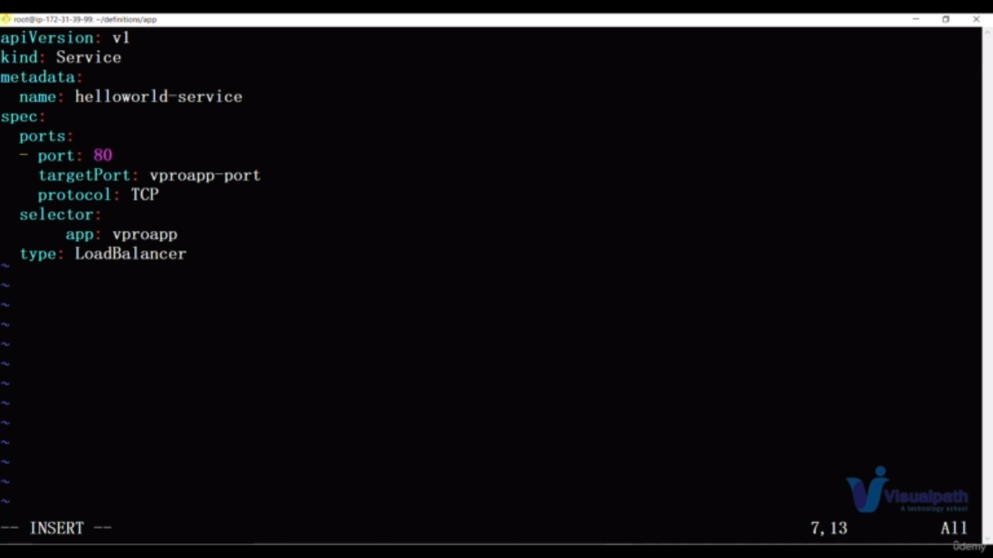



**ClusterIp:**

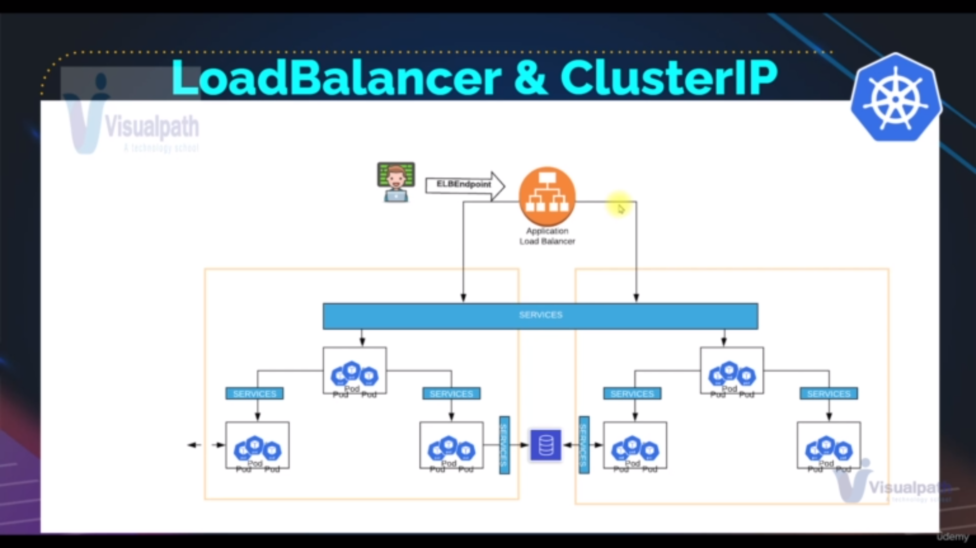

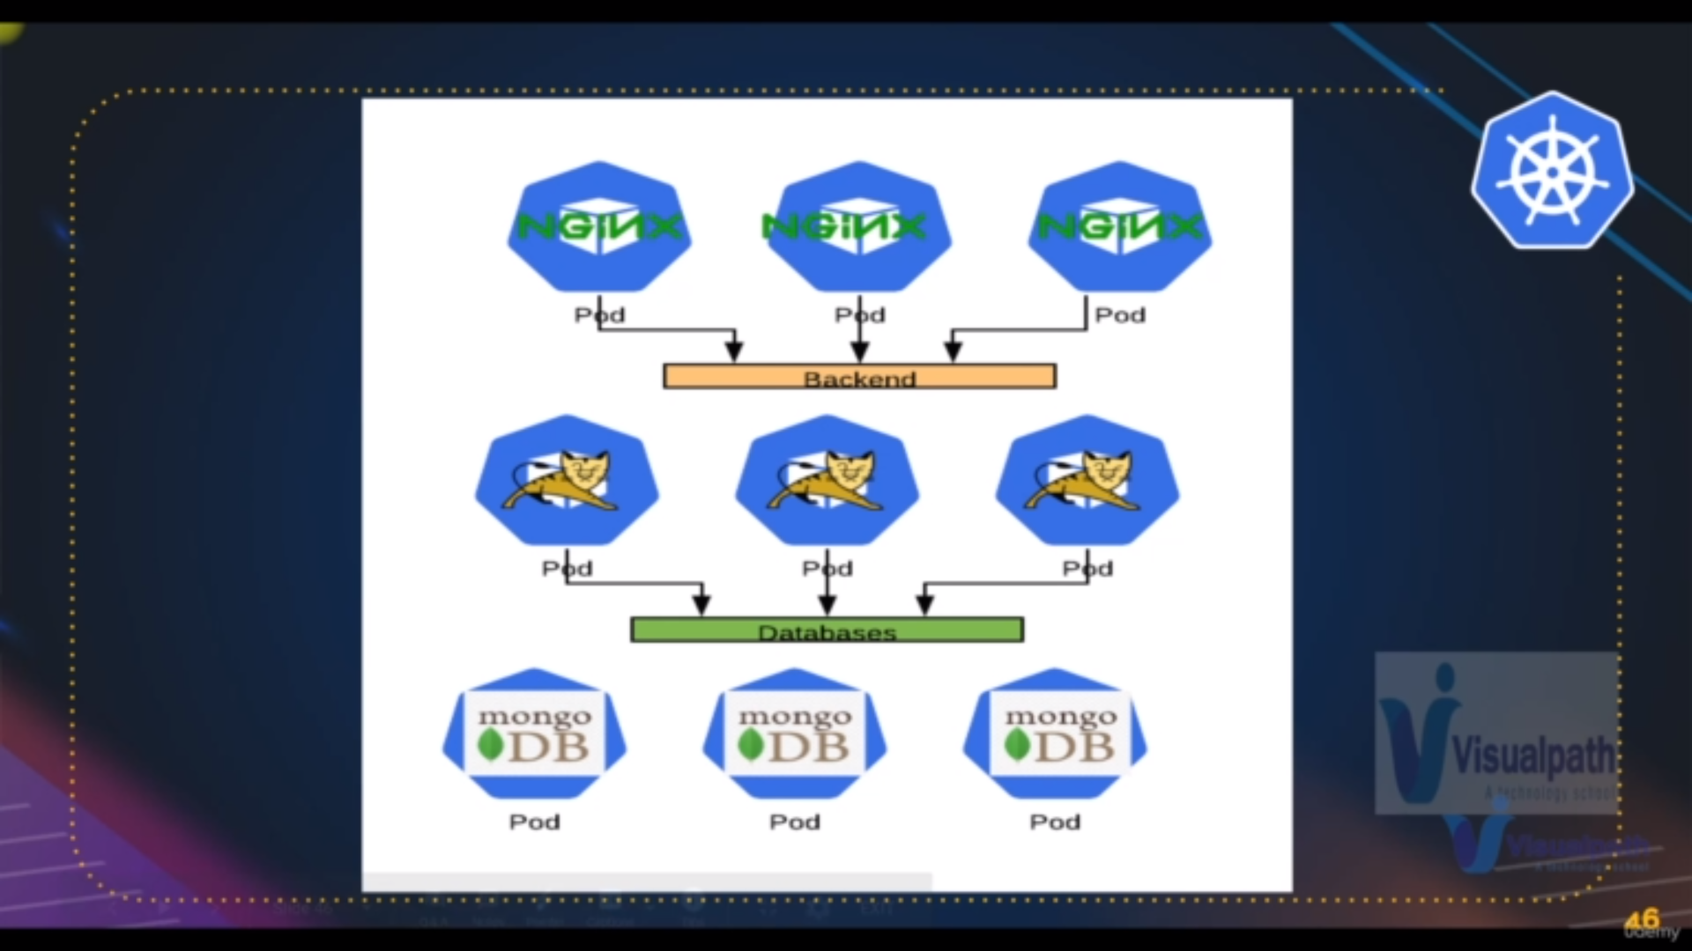clusterip flow

**cluster ip is basically for internal communication b/w pods**

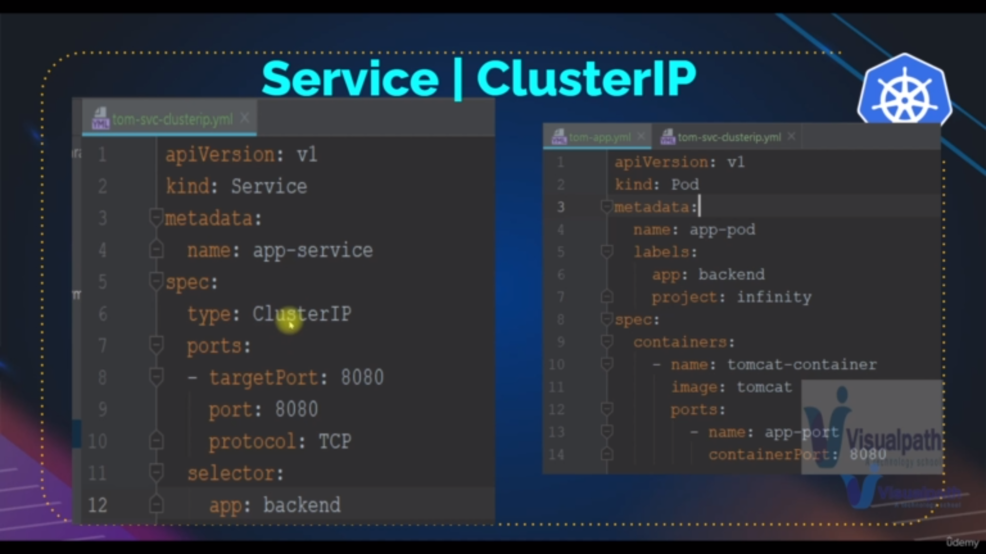yaml files for cluster ip

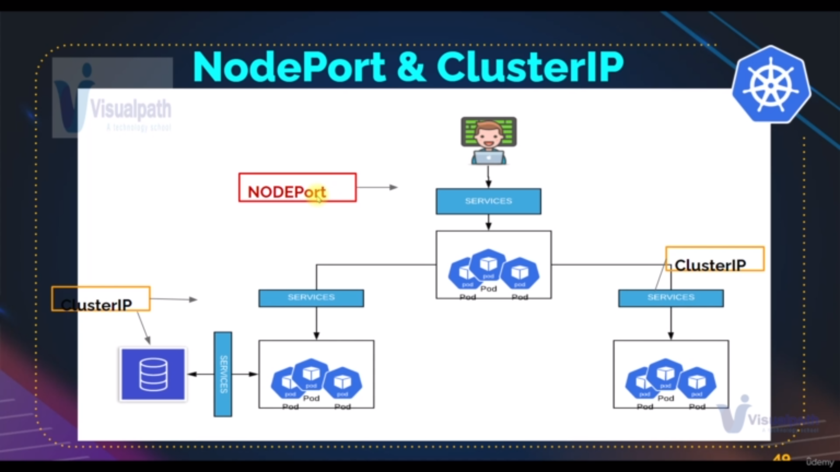node port and cluserip

**Replicaset:[object3]:**